PAGE 1 — AWS VPC / WINDOWS VPN PRACTICAL
Topic: Screenshot-wise practical step
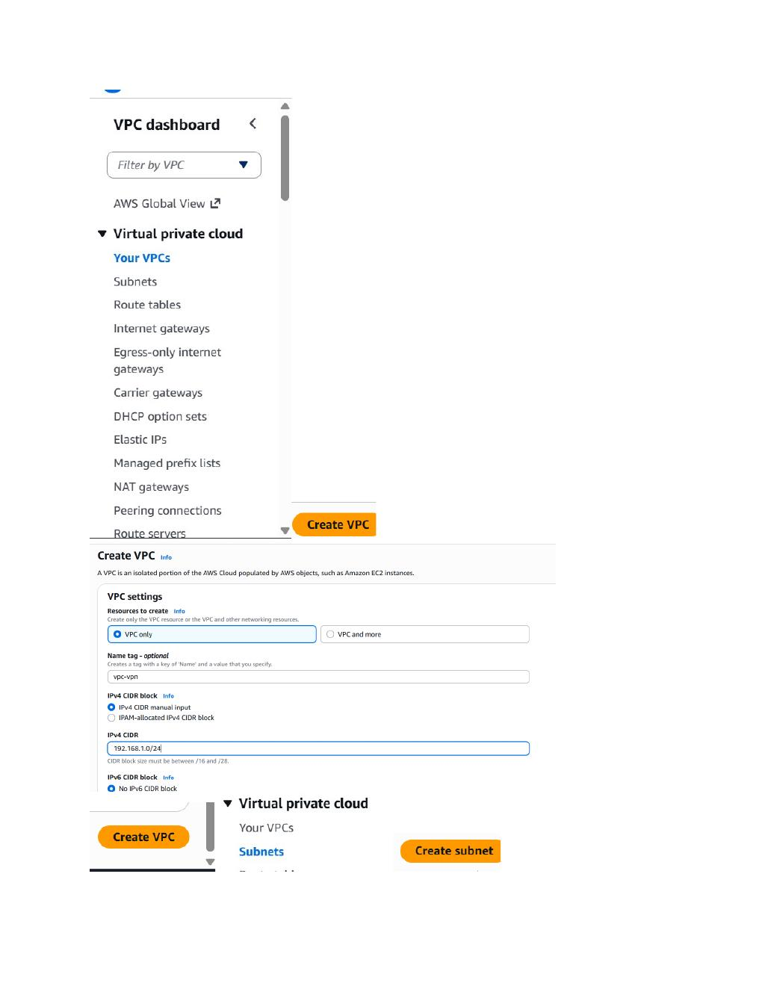
What I did:
Create the AWS VPC named “vpc-vpn” with IPv4 CIDR 192.168.1.0/24, then proceed to create the subnets inside this VPC.

PAGE 2 — AWS VPC / WINDOWS VPN PRACTICAL
Topic: Screenshot-wise practical step
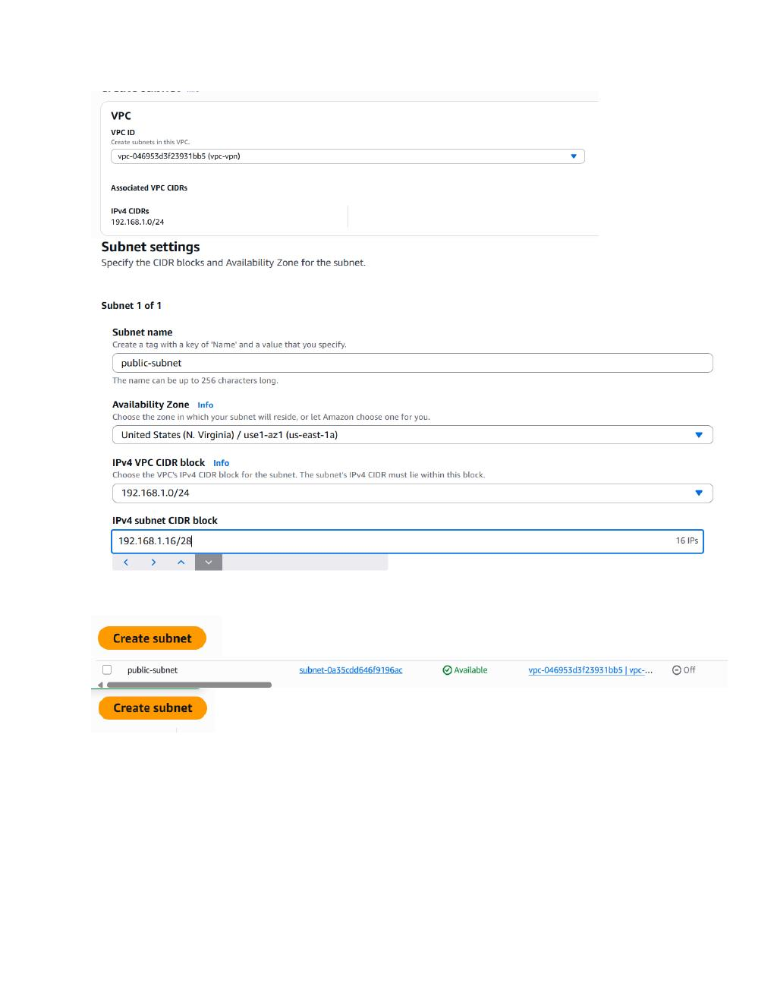
What I did:
Create the public subnet in the selected VPC, using Availability Zone us-east-1a and IPv4 subnet CIDR 192.168.1.16/28.

PAGE 3 — AWS VPC / WINDOWS VPN PRACTICAL
Topic: Screenshot-wise practical step
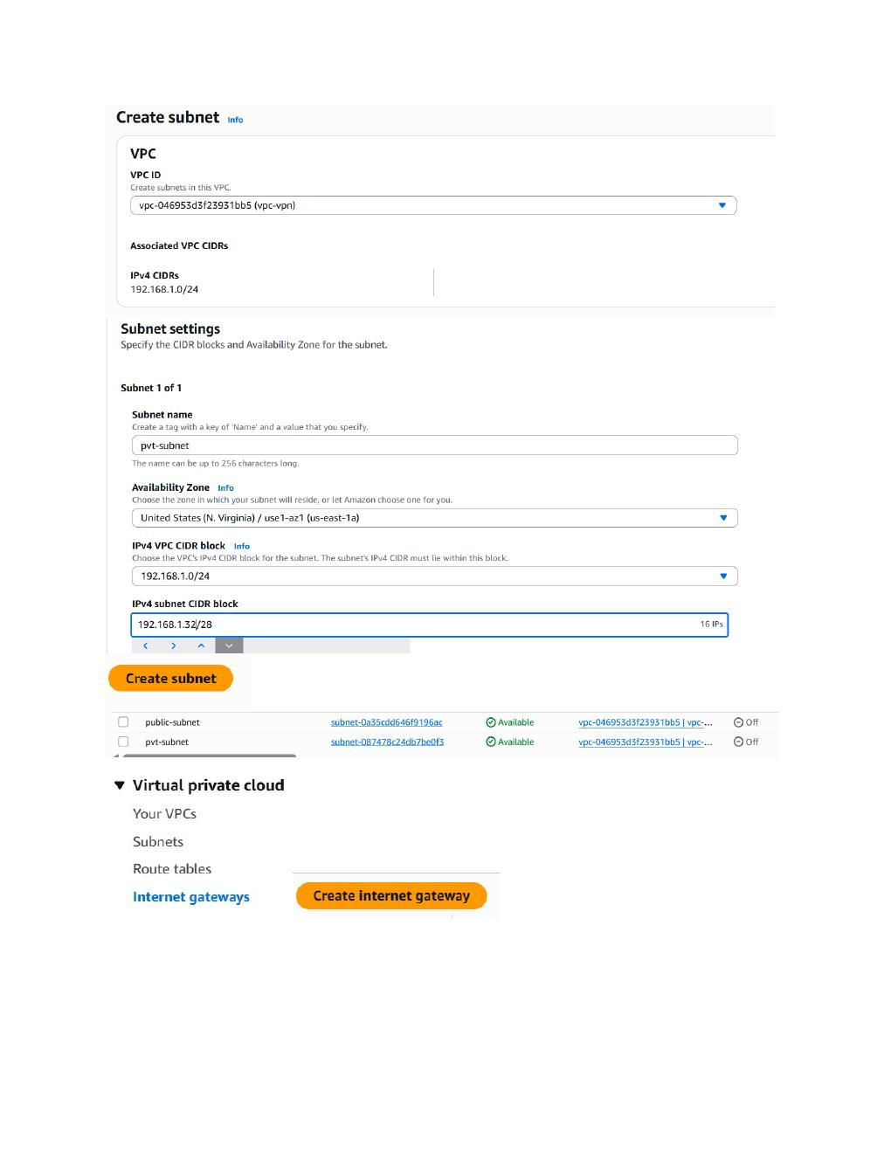
What I did:
Create the private subnet named “pvt-subnet” in the same VPC with IPv4 subnet CIDR 192.168.1.32/28.

PAGE 4 — AWS VPC / WINDOWS VPN PRACTICAL
Topic: Screenshot-wise practical step
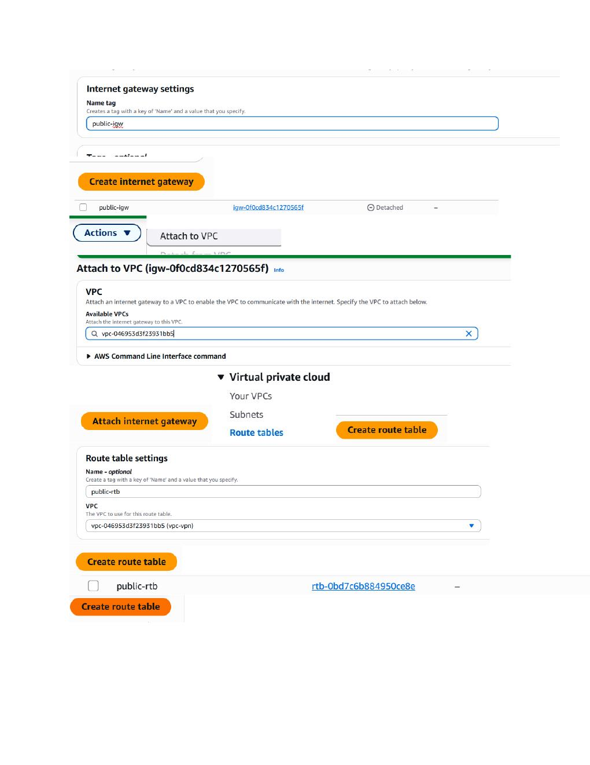
What I did:
Create the Internet Gateway named “public-igw”, attach it to the VPC, and create the route table named “public-rtb”.

PAGE 5 — AWS VPC / WINDOWS VPN PRACTICAL
Topic: Screenshot-wise practical step
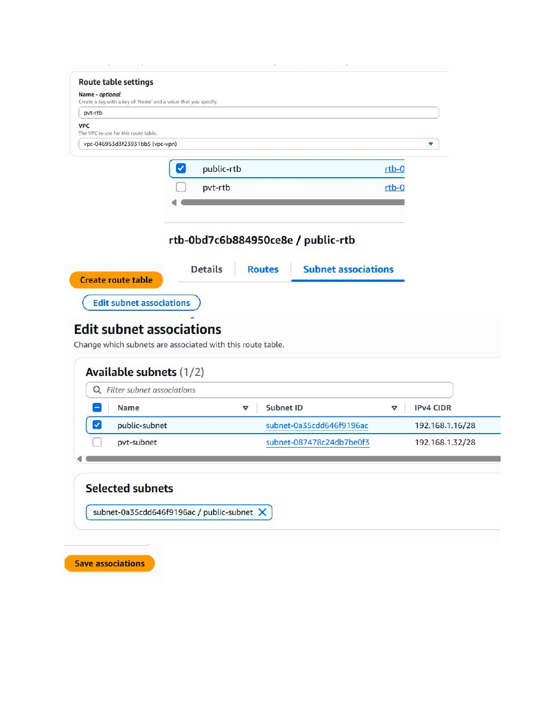
What I did:
Create the private route table “pvt-rtb” and associate the public subnet with “public-rtb” through Subnet associations.

PAGE 6 — AWS VPC / WINDOWS VPN PRACTICAL
Topic: Screenshot-wise practical step
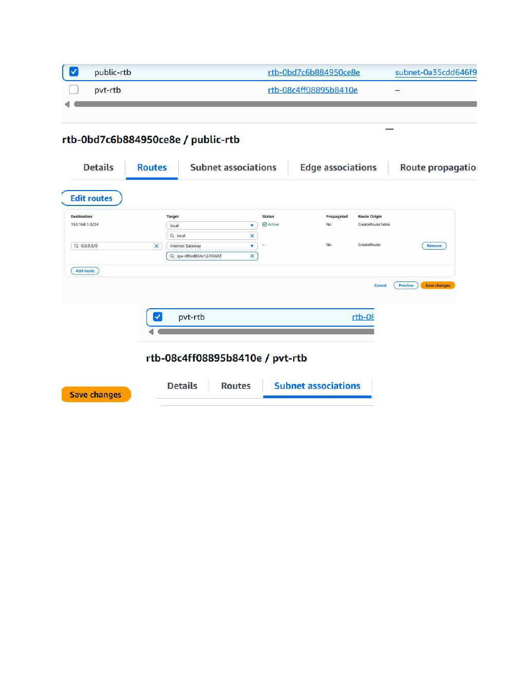
What I did:
Edit the public route table and add the default route 0.0.0.0/0 with the Internet Gateway as the target, then save the route changes.

PAGE 7 — AWS VPC / WINDOWS VPN PRACTICAL
Topic: Screenshot-wise practical step
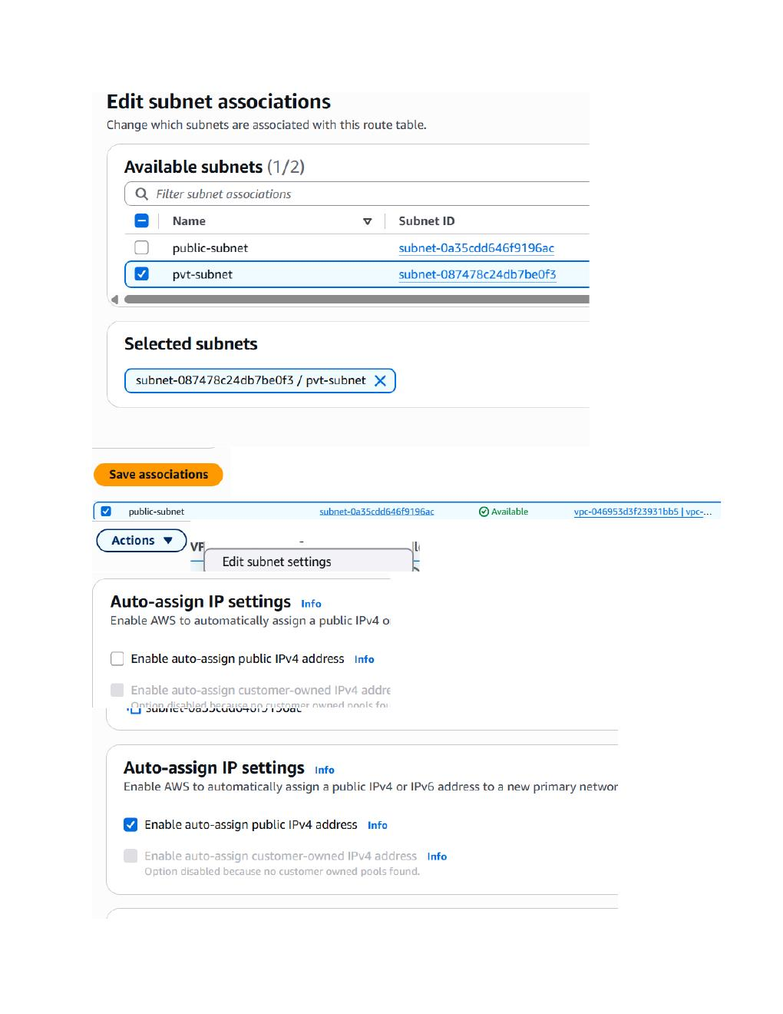
What I did:
Associate the private subnet with “pvt-rtb”; the screenshot also shows enabling auto-assign public IPv4 for the public subnet.

PAGE 8 — AWS VPC / WINDOWS VPN PRACTICAL
Topic: Screenshot-wise practical step
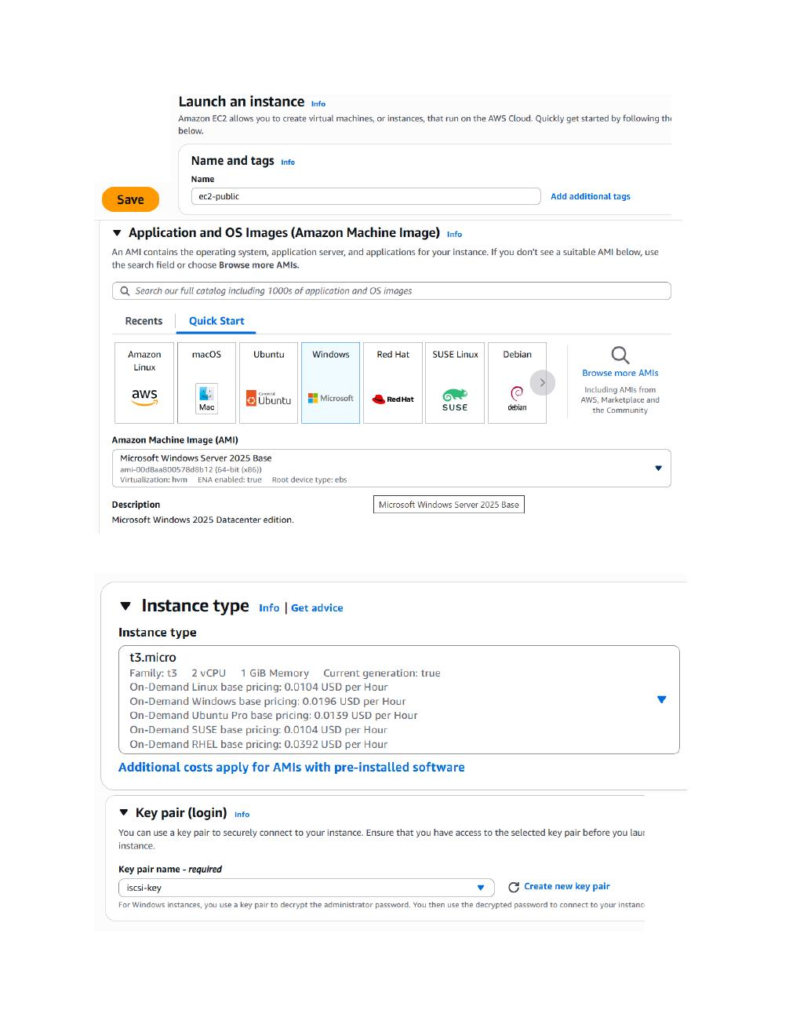
What I did:
Launch the public EC2 instance: name it “ec2-public”, select Microsoft Windows Server 2025 Base, use t3.micro, and select the “icsi-key” key pair.

PAGE 9 — AWS VPC / WINDOWS VPN PRACTICAL
Topic: Screenshot-wise practical step
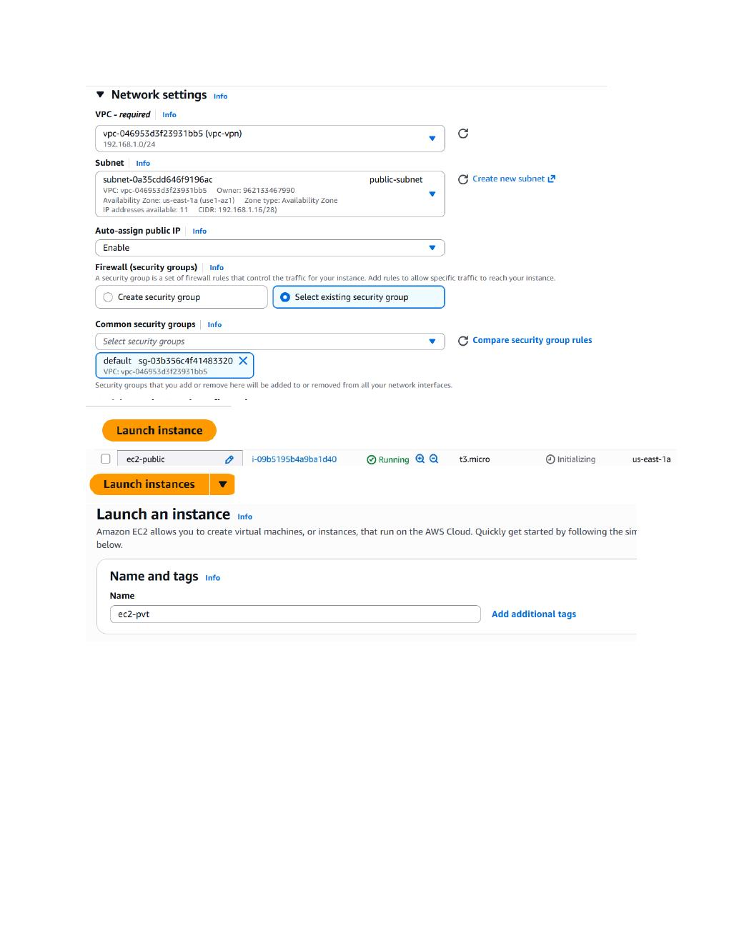
What I did:
Configure the public instance network settings with the created VPC and public subnet, enable public IP assignment, select the existing security group, and launch the instance. The next launch form starts the private instance.

PAGE 10 — AWS VPC / WINDOWS VPN PRACTICAL
Topic: Screenshot-wise practical step
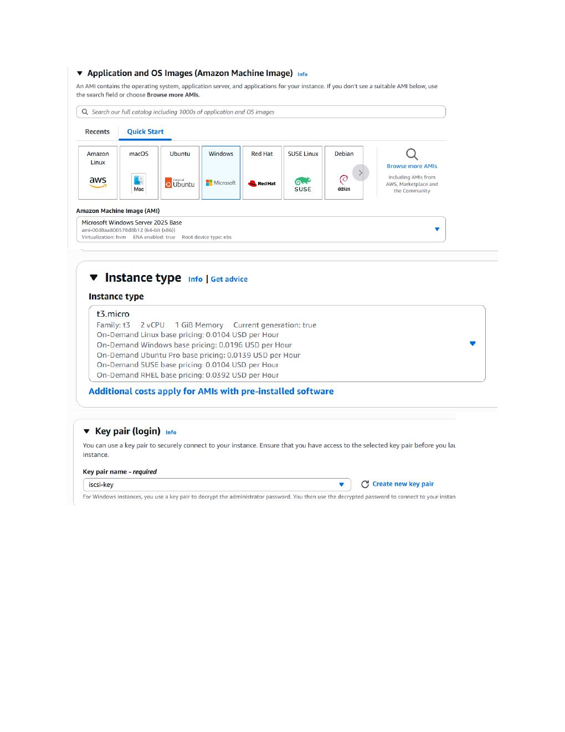
What I did:
Configure the private EC2 instance using Microsoft Windows Server 2025 Base, t3.micro, and the “icsi-key” key pair.

PAGE 11 — AWS VPC / WINDOWS VPN PRACTICAL
Topic: Screenshot-wise practical step
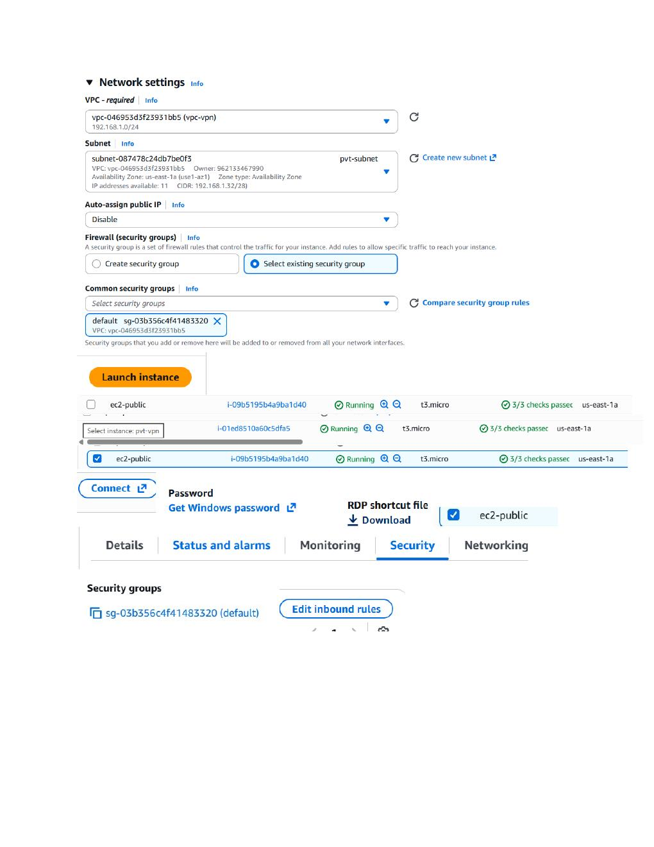
What I did:
Place the private instance in “pvt-subnet”, disable public IP assignment, launch it, then select the running public instance and open its Connect/Security area.

PAGE 12 — AWS VPC / WINDOWS VPN PRACTICAL
Topic: Screenshot-wise practical step
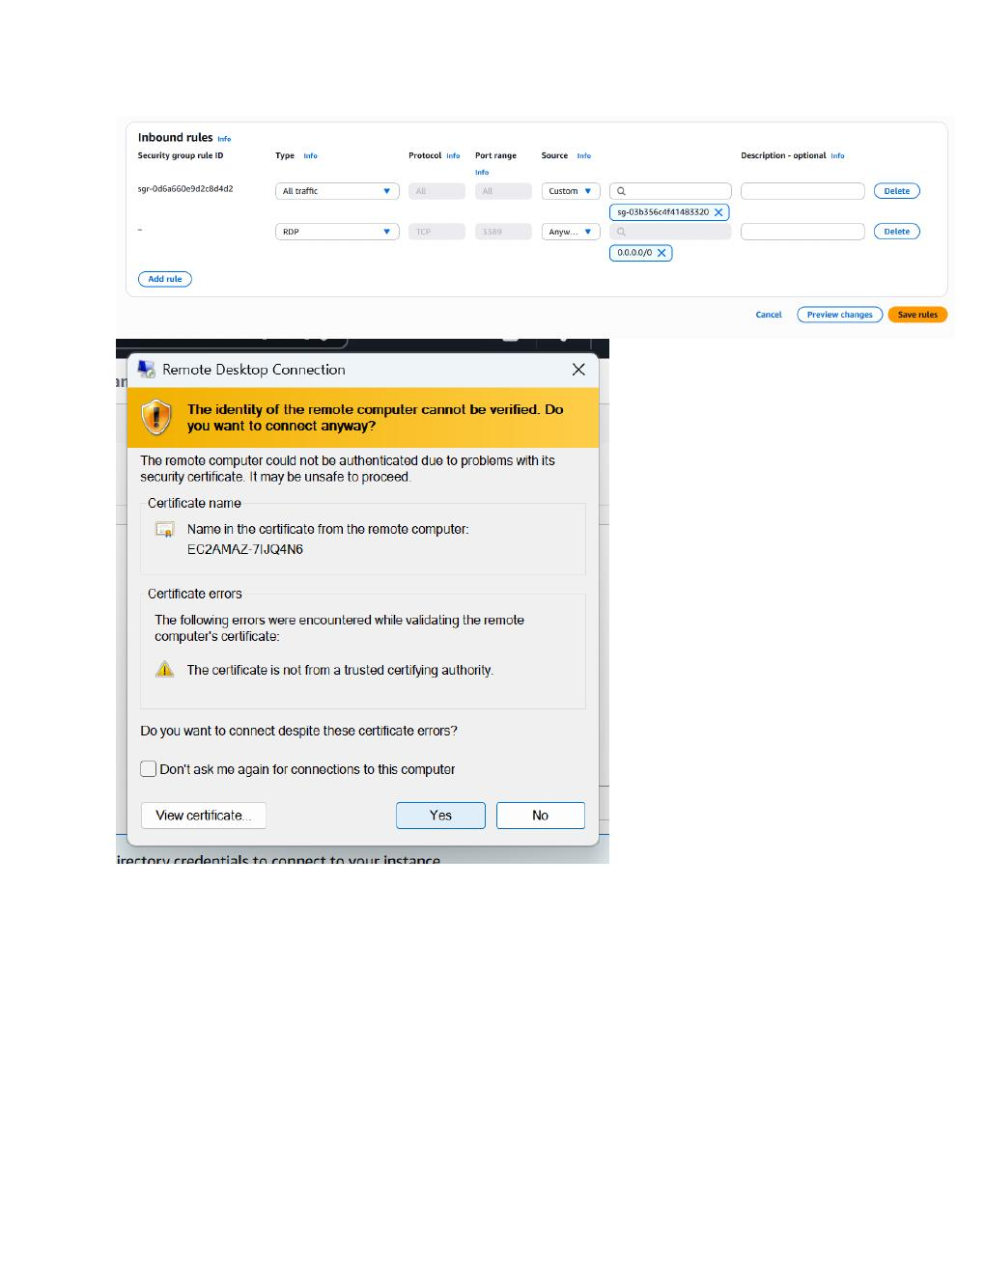
What I did:
Edit the security group inbound rules to allow RDP on TCP port 3389 from 0.0.0.0/0; the screenshot also shows the RDP certificate warning when connecting to the Windows server.

PAGE 13 — AWS VPC / WINDOWS VPN PRACTICAL
Topic: Screenshot-wise practical step
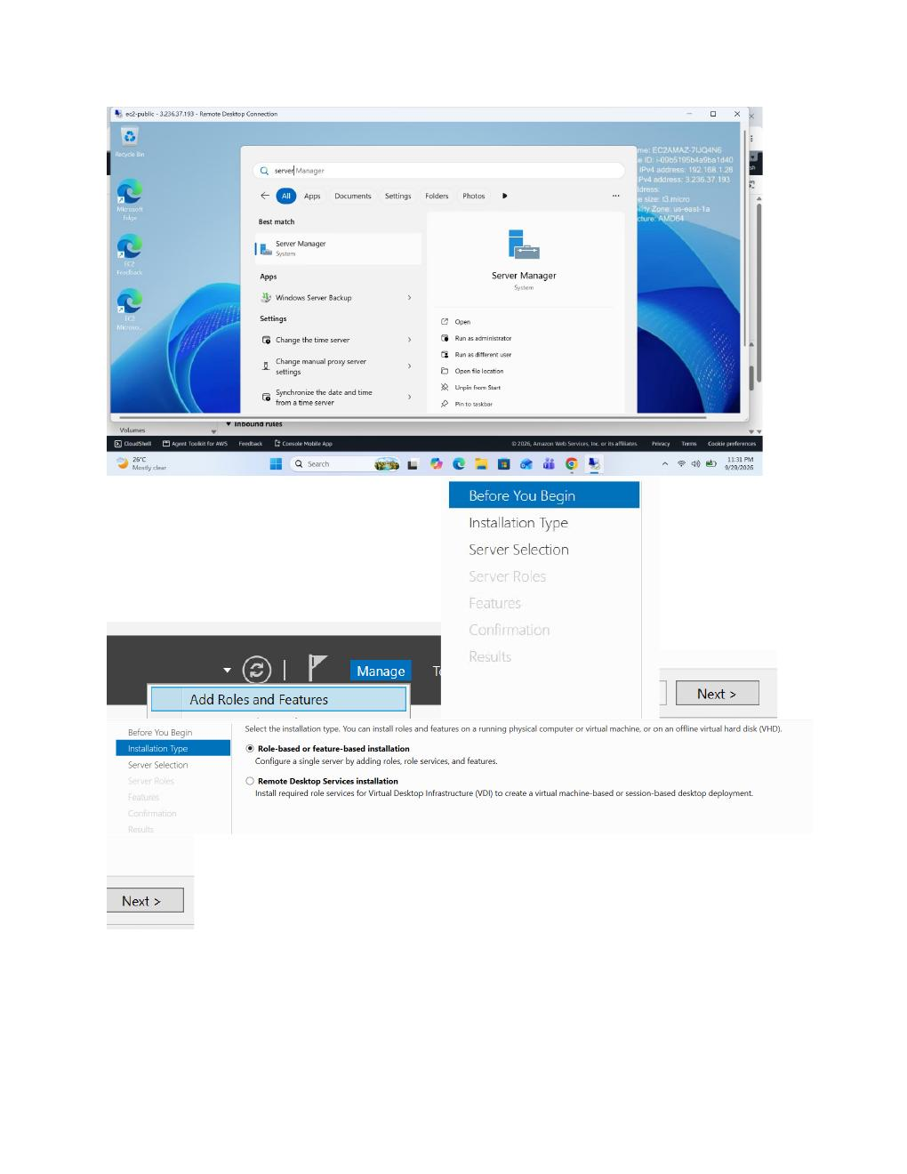
What I did:
Connect to the running Windows EC2 server through RDP and open Server Manager; start Add Roles and Features from the Manage menu.

PAGE 14 — AWS VPC / WINDOWS VPN PRACTICAL
Topic: Screenshot-wise practical step
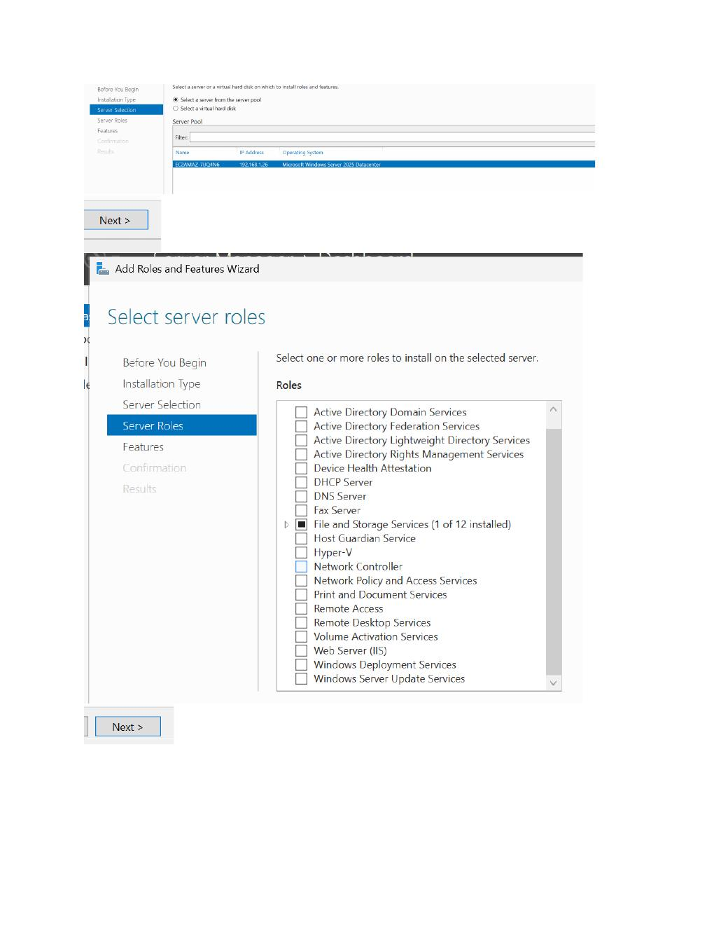
What I did:
Use the Add Roles and Features wizard to continue with the role-based or feature-based installation option for the Windows Server.

PAGE 15 — AWS VPC / WINDOWS VPN PRACTICAL
Topic: Screenshot-wise practical step
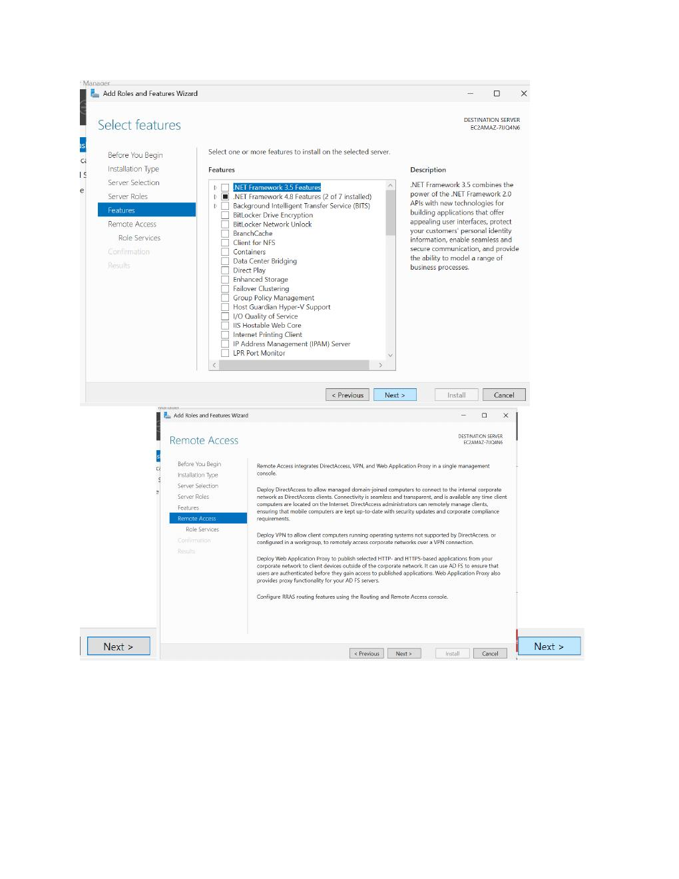
What I did:
Select the destination Windows Server from the server pool so the required remote-access role can be installed.

PAGE 16 — AWS VPC / WINDOWS VPN PRACTICAL
Topic: Screenshot-wise practical step
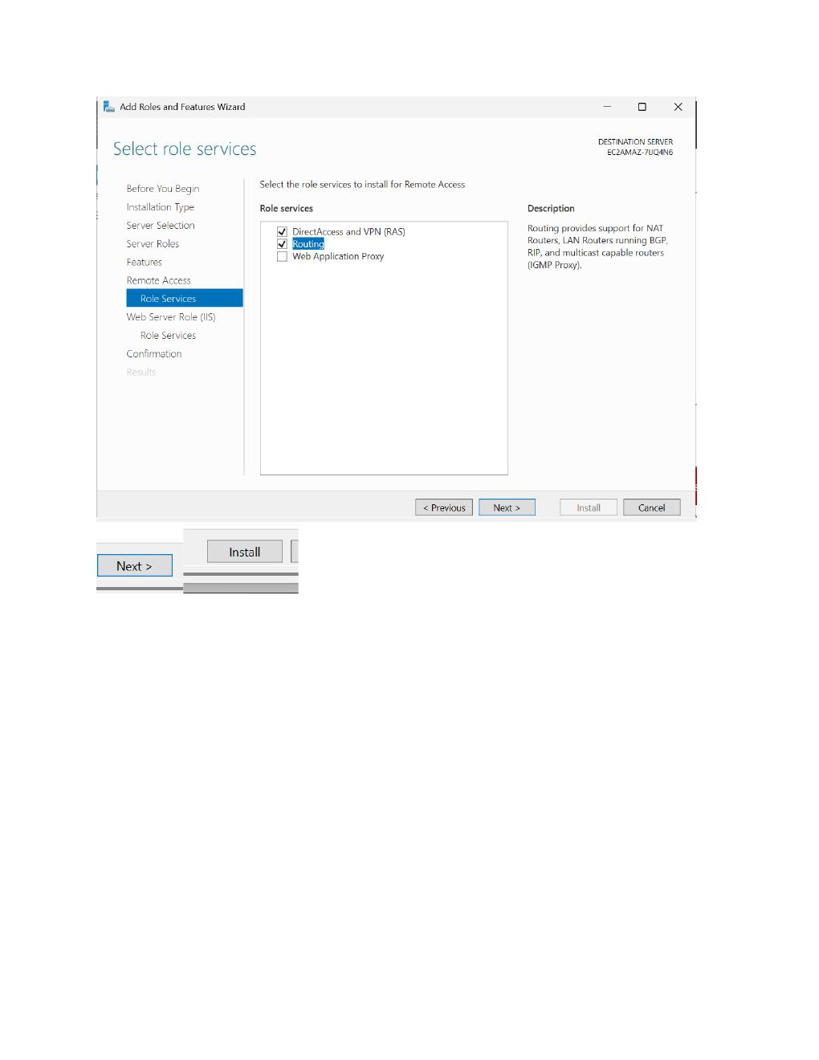
What I did:
Select the Remote Access server role in Server Roles and continue through the role installation wizard.

PAGE 17 — AWS VPC / WINDOWS VPN PRACTICAL
Topic: Screenshot-wise practical step
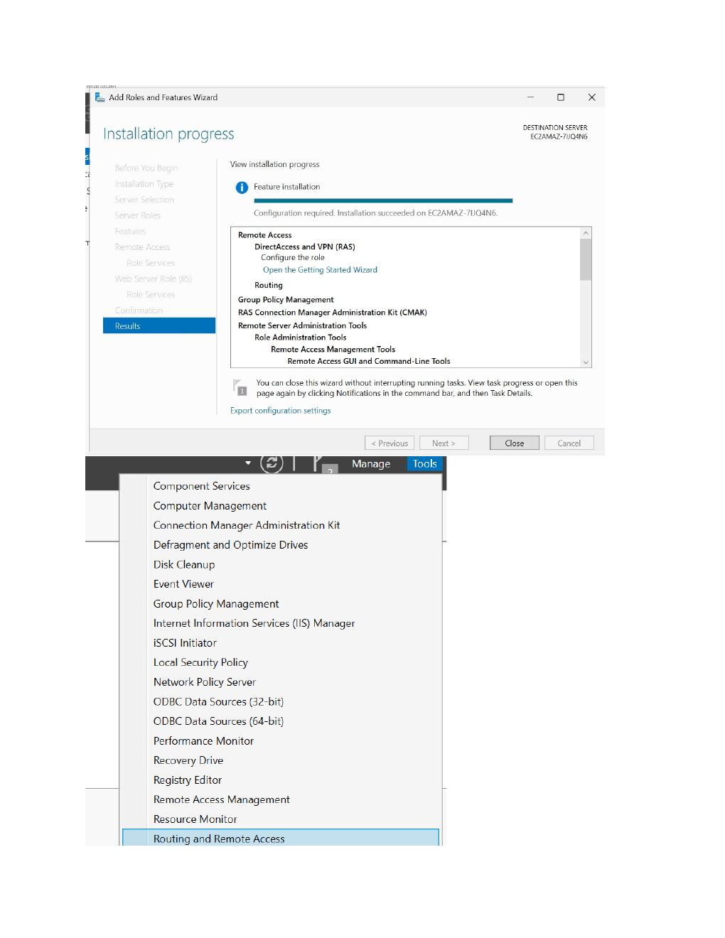
What I did:
Select the required Remote Access role services/features, then continue to the confirmation stage.

PAGE 18 — AWS VPC / WINDOWS VPN PRACTICAL
Topic: Screenshot-wise practical step
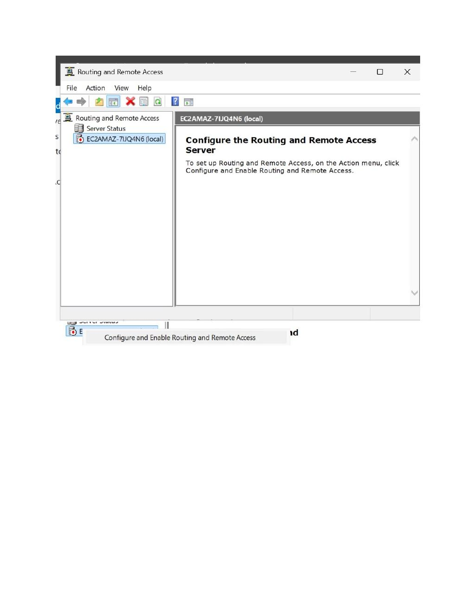
What I did:
Finish the role installation and open the Routing and Remote Access management console from the Windows Server administrative tools.

PAGE 19 — AWS VPC / WINDOWS VPN PRACTICAL
Topic: Screenshot-wise practical step
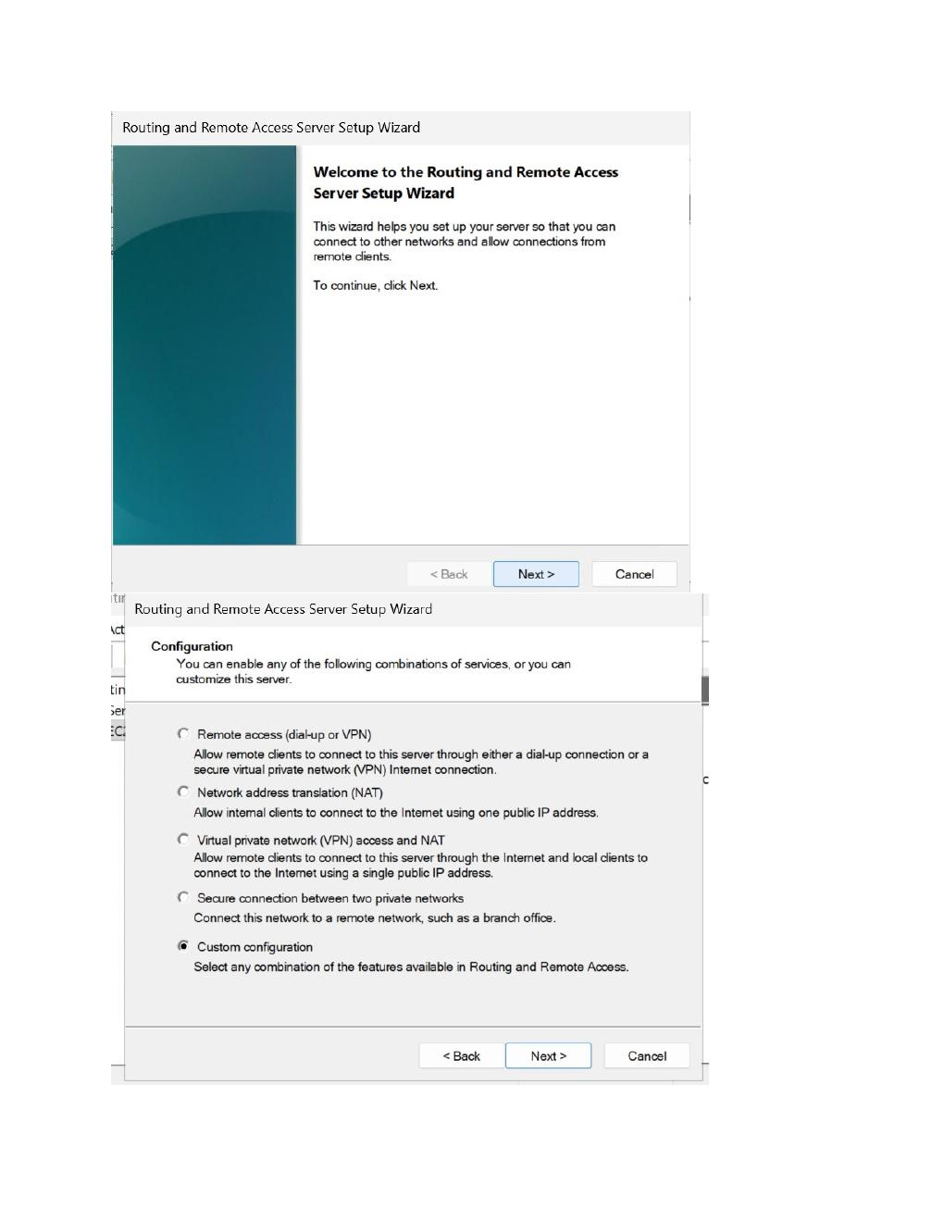
What I did:
Open the Routing and Remote Access setup area and begin configuring the server as a remote-access/VPN server.

PAGE 20 — AWS VPC / WINDOWS VPN PRACTICAL
Topic: Screenshot-wise practical step
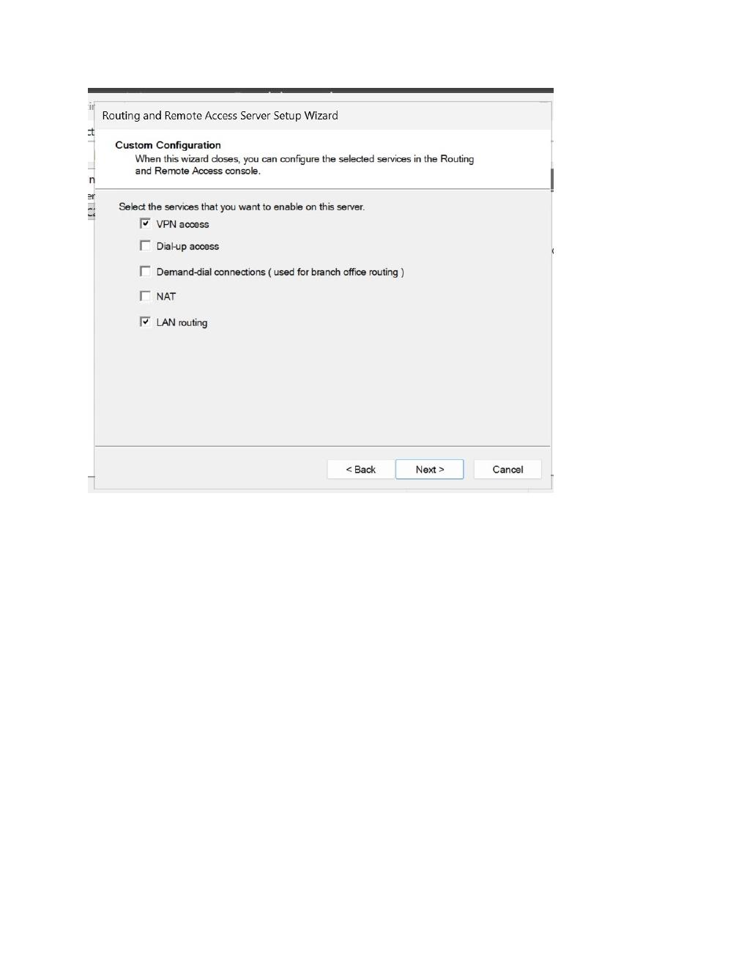
What I did:
Choose the custom configuration option in the Routing and Remote Access setup wizard to configure the required VPN services.

PAGE 21 — AWS VPC / WINDOWS VPN PRACTICAL
Topic: Screenshot-wise practical step
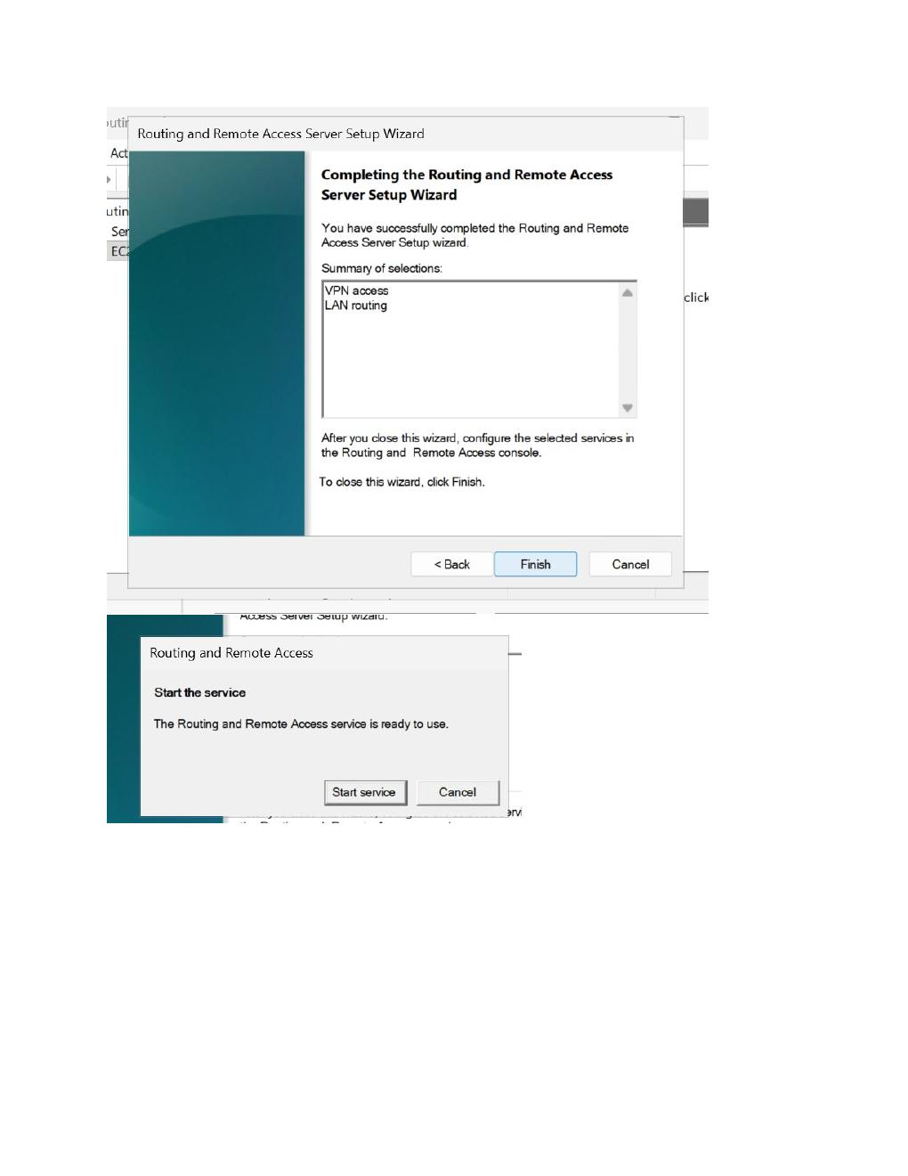
What I did:
Select VPN access in the custom configuration so the Windows Server can accept VPN client connections.

PAGE 22 — AWS VPC / WINDOWS VPN PRACTICAL
Topic: Screenshot-wise practical step
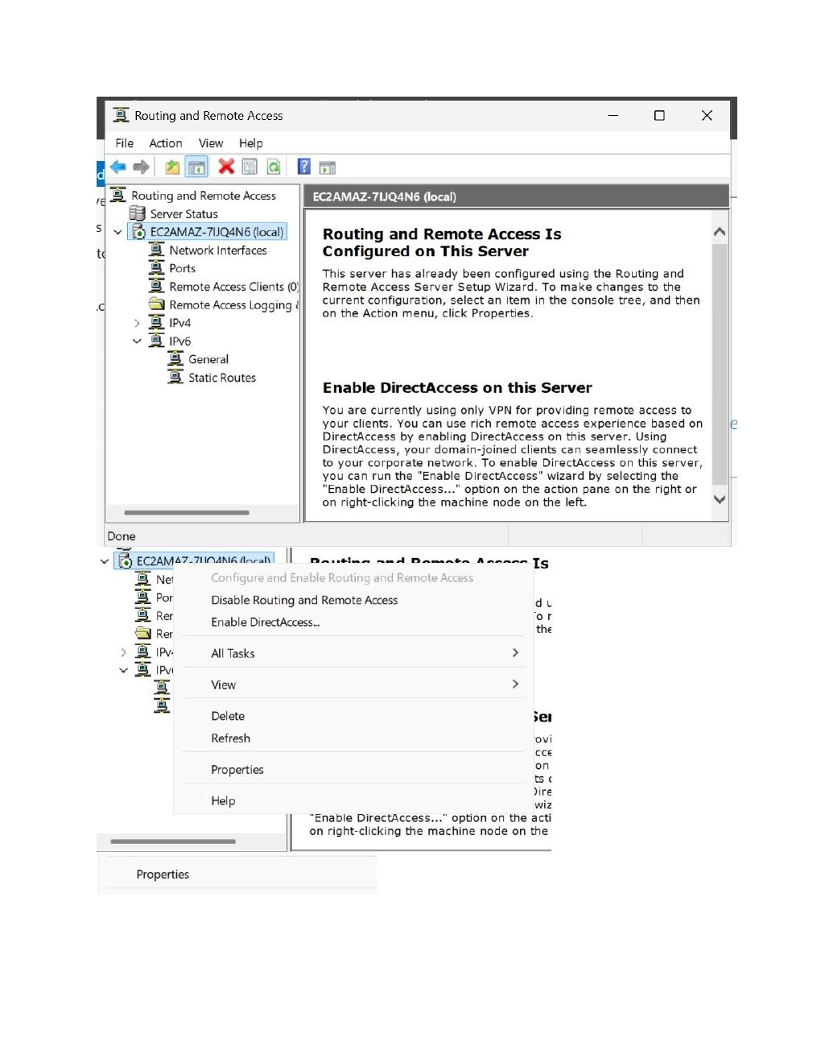
What I did:
Complete the Routing and Remote Access configuration and apply the selected VPN settings to the server.

PAGE 23 — AWS VPC / WINDOWS VPN PRACTICAL
Topic: Screenshot-wise practical step
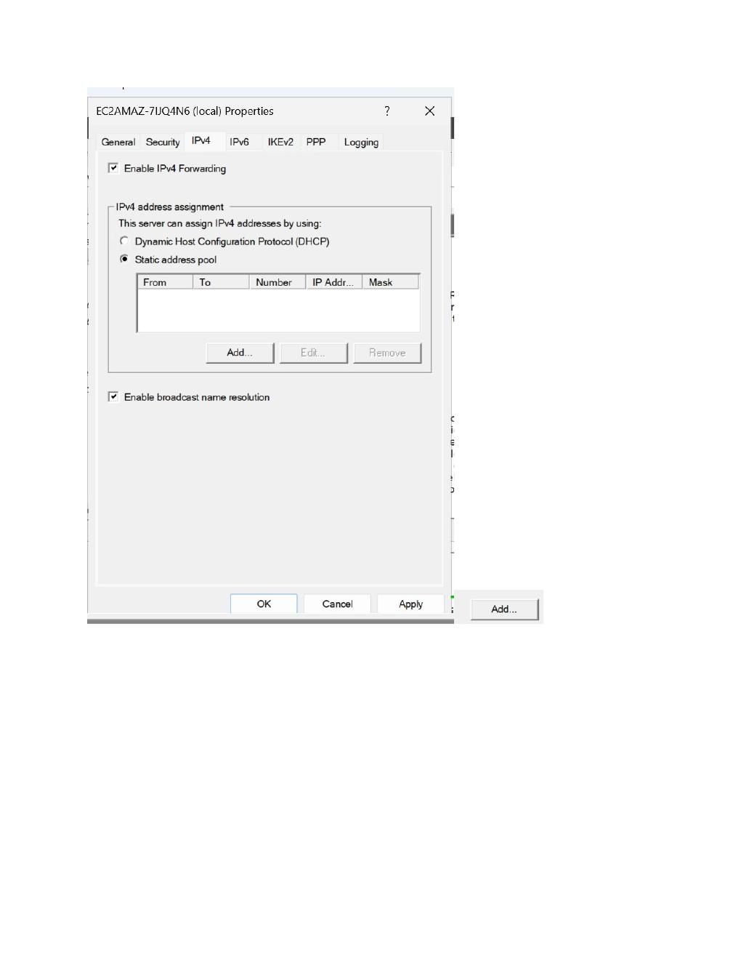
What I did:
Open the Routing and Remote Access server properties/configuration and review the VPN server settings.

PAGE 24 — AWS VPC / WINDOWS VPN PRACTICAL
Topic: Screenshot-wise practical step
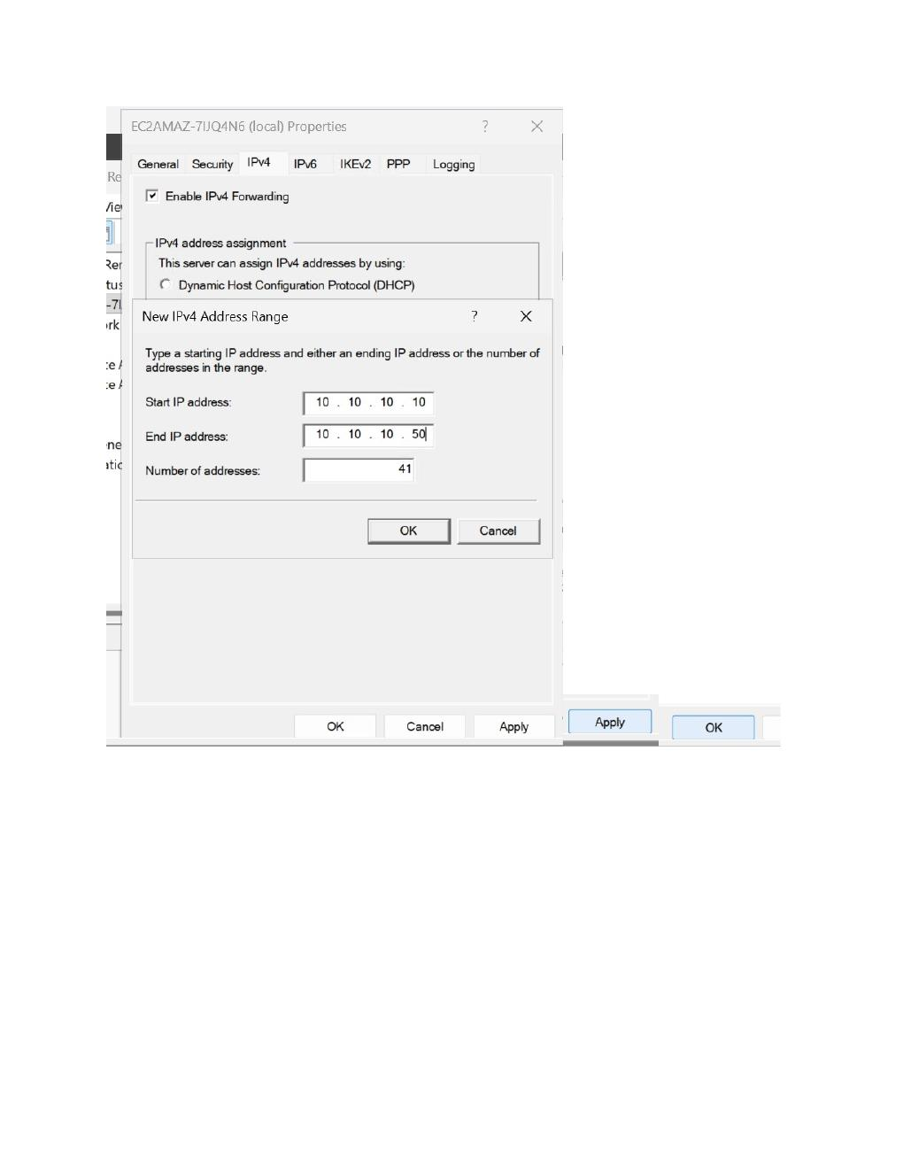
What I did:
Open the IPv4 configuration section and review how IPv4 addressing will be handled for incoming VPN clients.

PAGE 25 — AWS VPC / WINDOWS VPN PRACTICAL
Topic: Screenshot-wise practical step
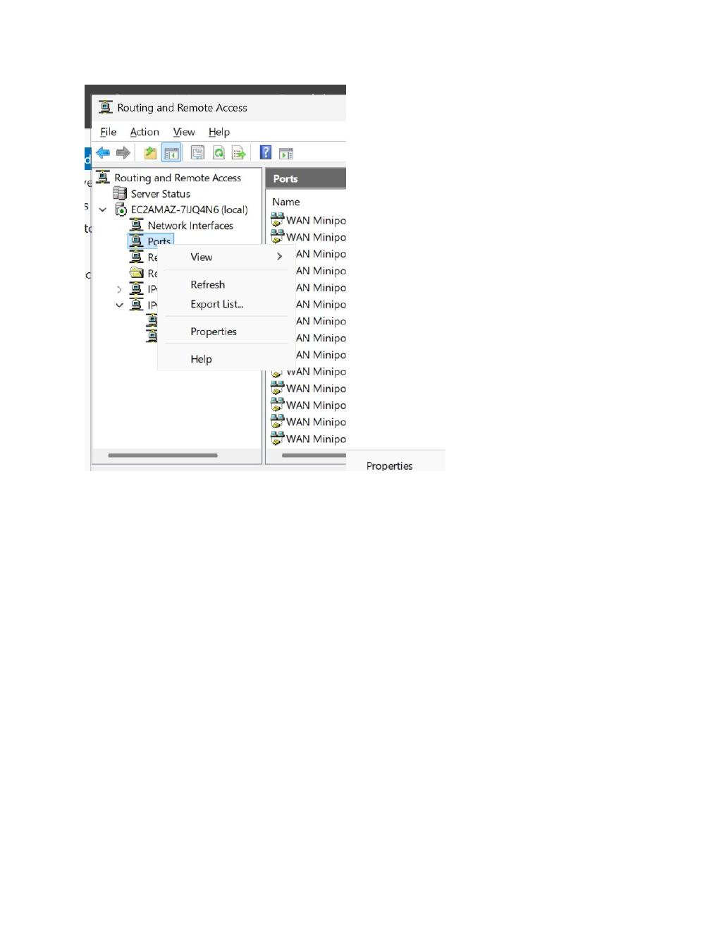
What I did:
Configure the VPN client address pool/static address range so connected VPN clients can receive addresses.

PAGE 26 — AWS VPC / WINDOWS VPN PRACTICAL
Topic: Screenshot-wise practical step
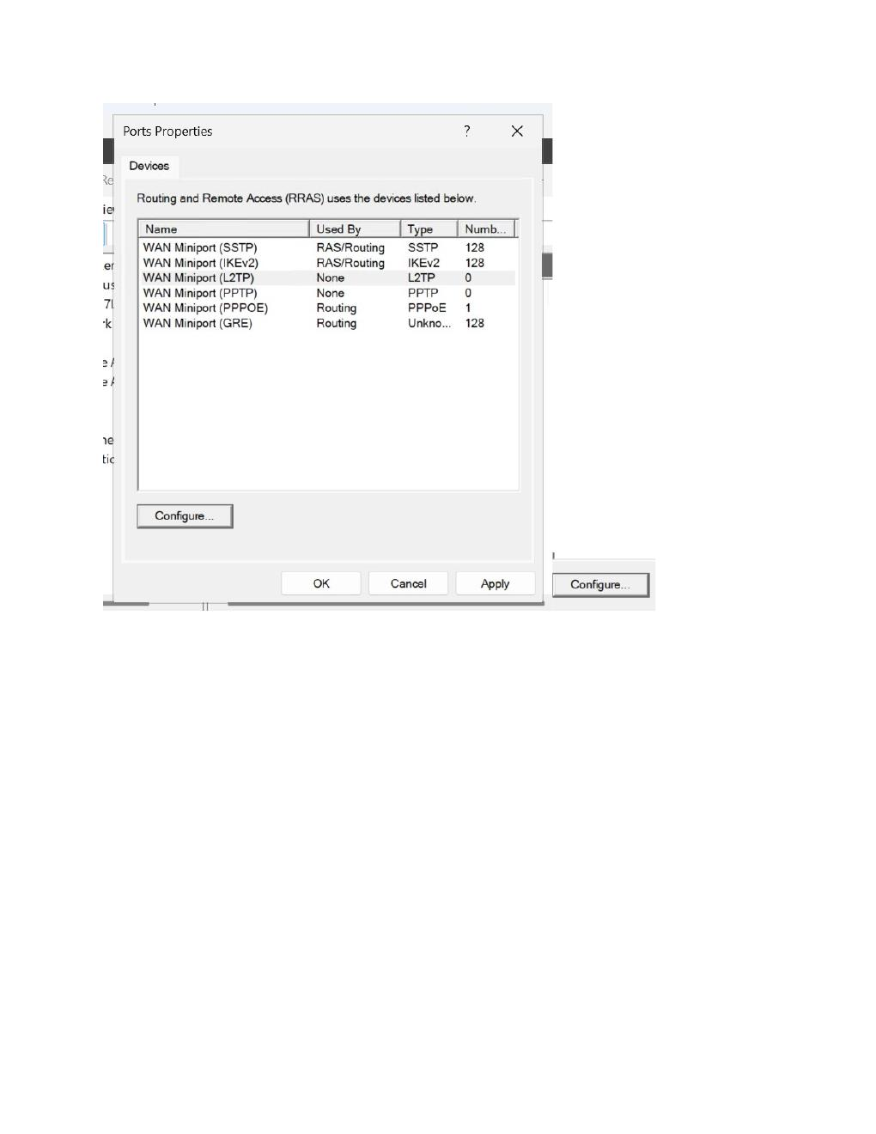
What I did:
Review the network interfaces available to Routing and Remote Access and select the appropriate server network interface.

PAGE 27 — AWS VPC / WINDOWS VPN PRACTICAL
Topic: Screenshot-wise practical step
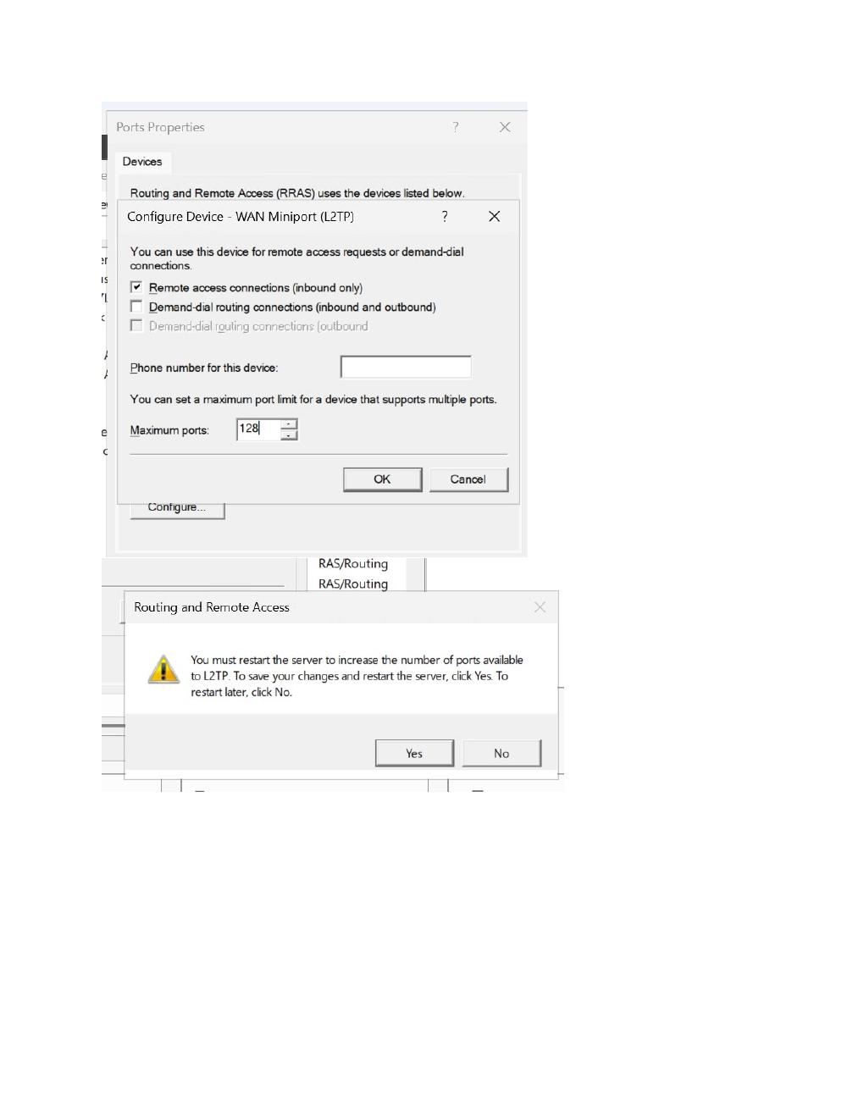
What I did:
Review the VPN/security configuration options used by Routing and Remote Access before applying the settings.

PAGE 28 — AWS VPC / WINDOWS VPN PRACTICAL
Topic: Screenshot-wise practical step
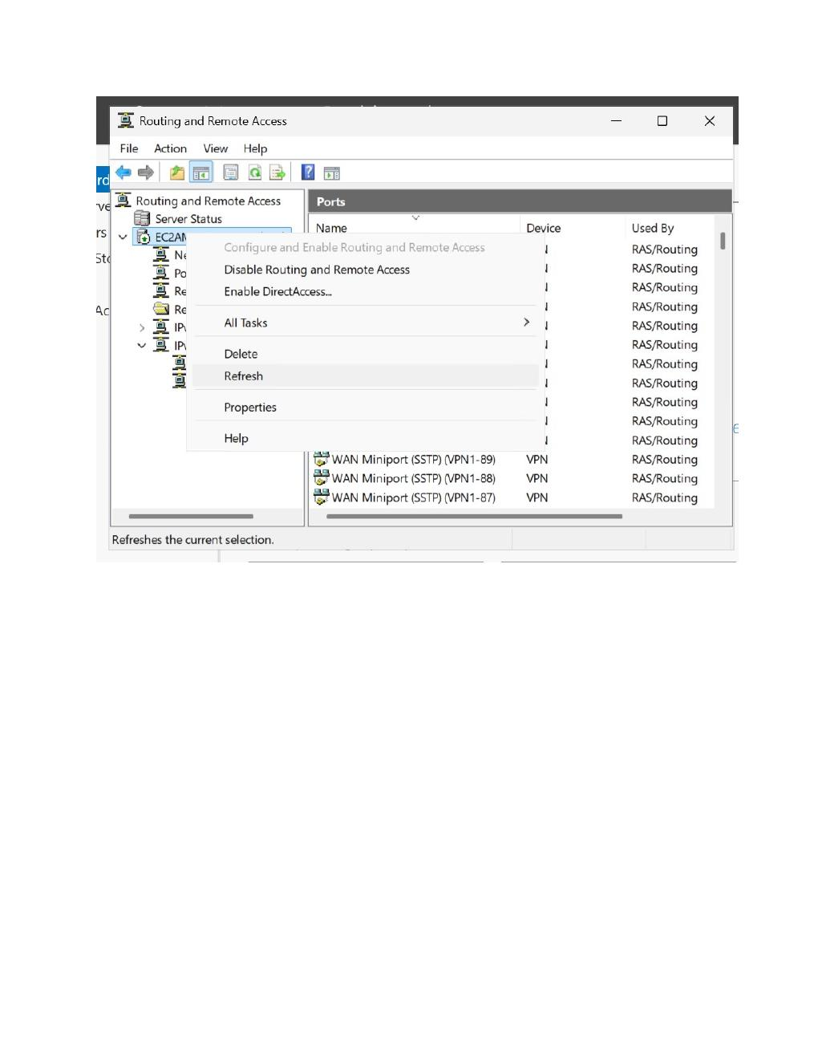
What I did:
Open the Windows user/account management area to prepare the account that will be allowed to use the VPN connection.

PAGE 29 — AWS VPC / WINDOWS VPN PRACTICAL
Topic: Screenshot-wise practical step
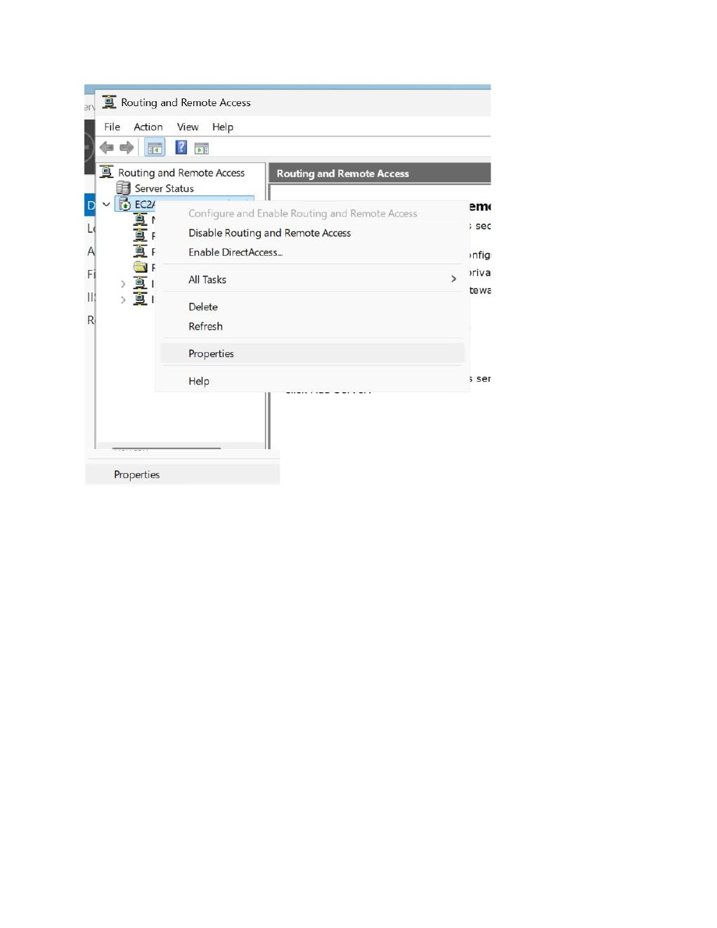
What I did:
Open Network Connections and review the available network adapters/connections on the Windows Server.

PAGE 30 — AWS VPC / WINDOWS VPN PRACTICAL
Topic: Screenshot-wise practical step
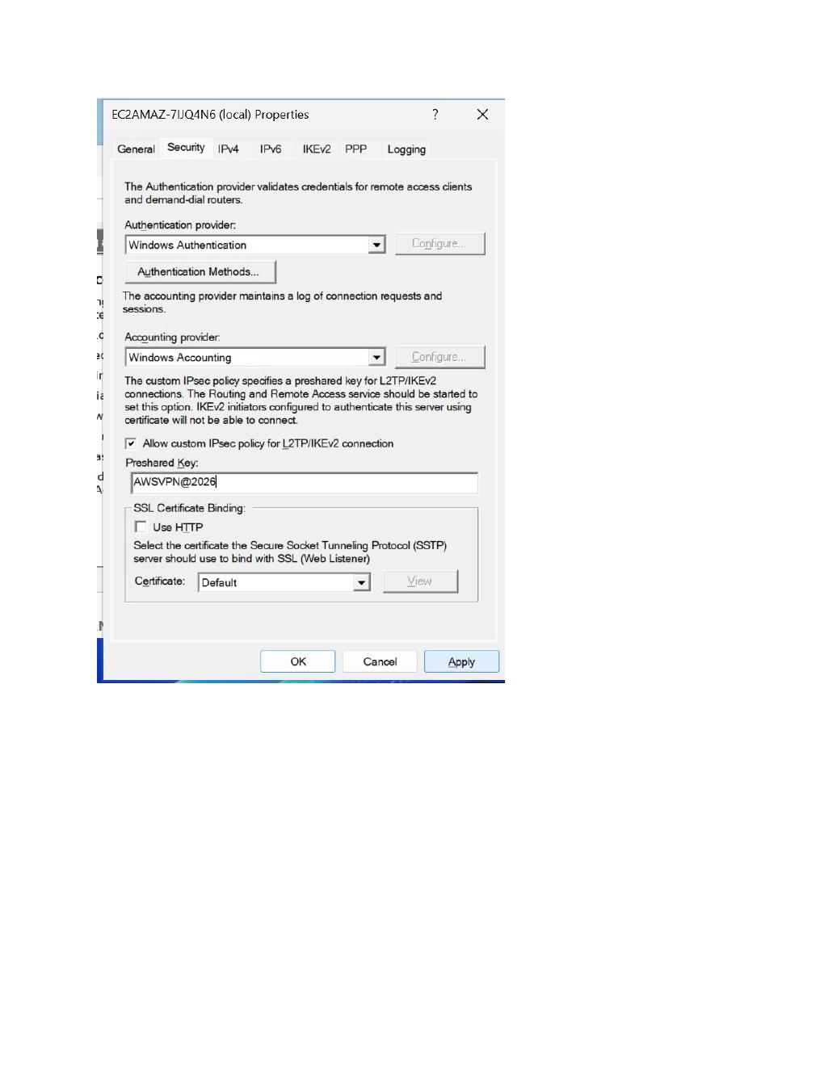
What I did:
Open the incoming/VPN connection configuration and review the connection properties used for remote access.

PAGE 31 — AWS VPC / WINDOWS VPN PRACTICAL
Topic: Screenshot-wise practical step
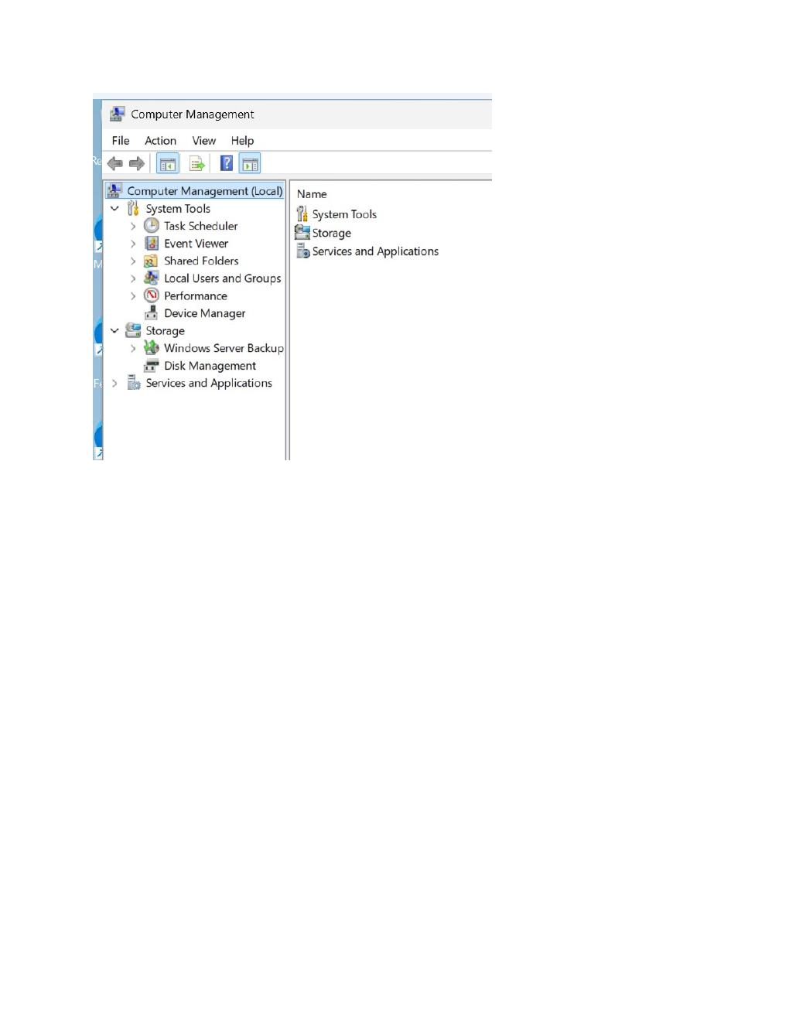
What I did:
Open the selected user account properties and configure the Remote Access/Dial-in permission for VPN access.

PAGE 32 — AWS VPC / WINDOWS VPN PRACTICAL
Topic: Screenshot-wise practical step
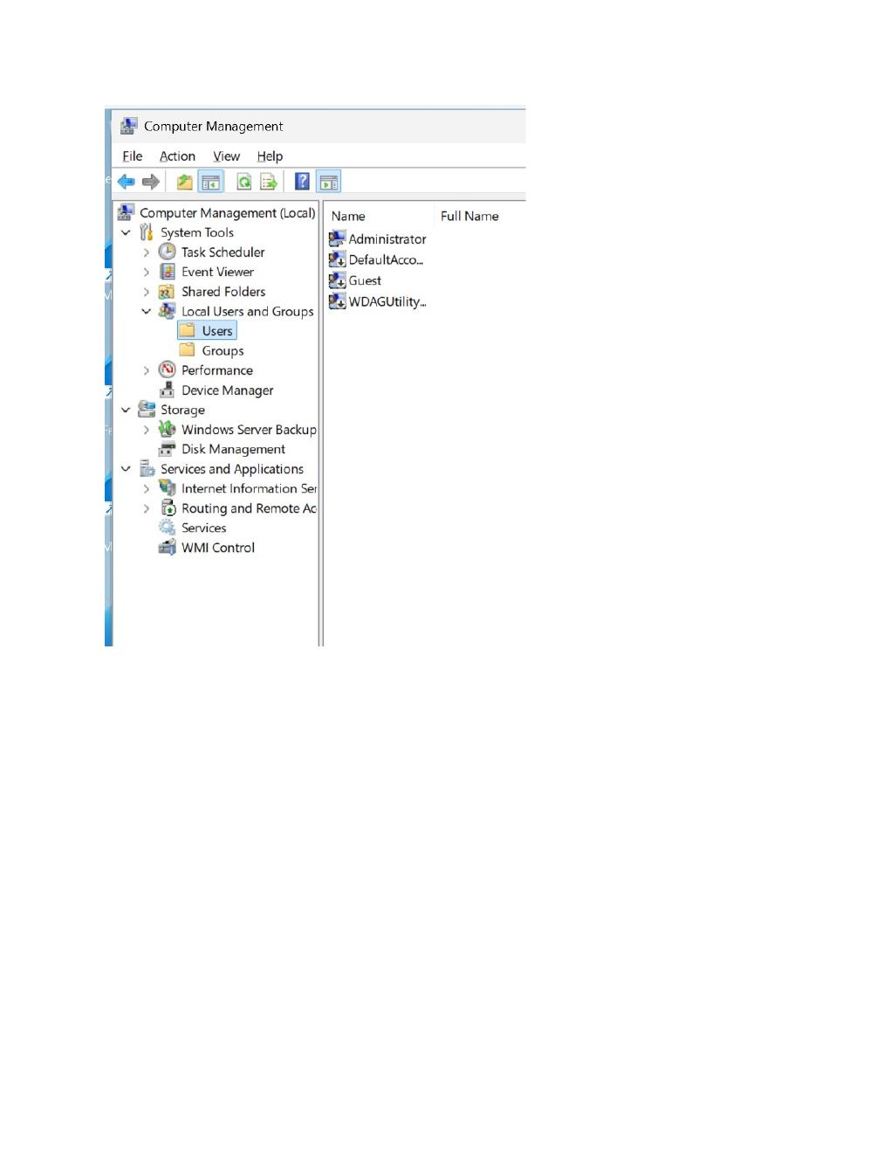
What I did:
Return to the Routing and Remote Access console and review the configured VPN server and connection settings.

PAGE 33 — AWS VPC / WINDOWS VPN PRACTICAL
Topic: Screenshot-wise practical step
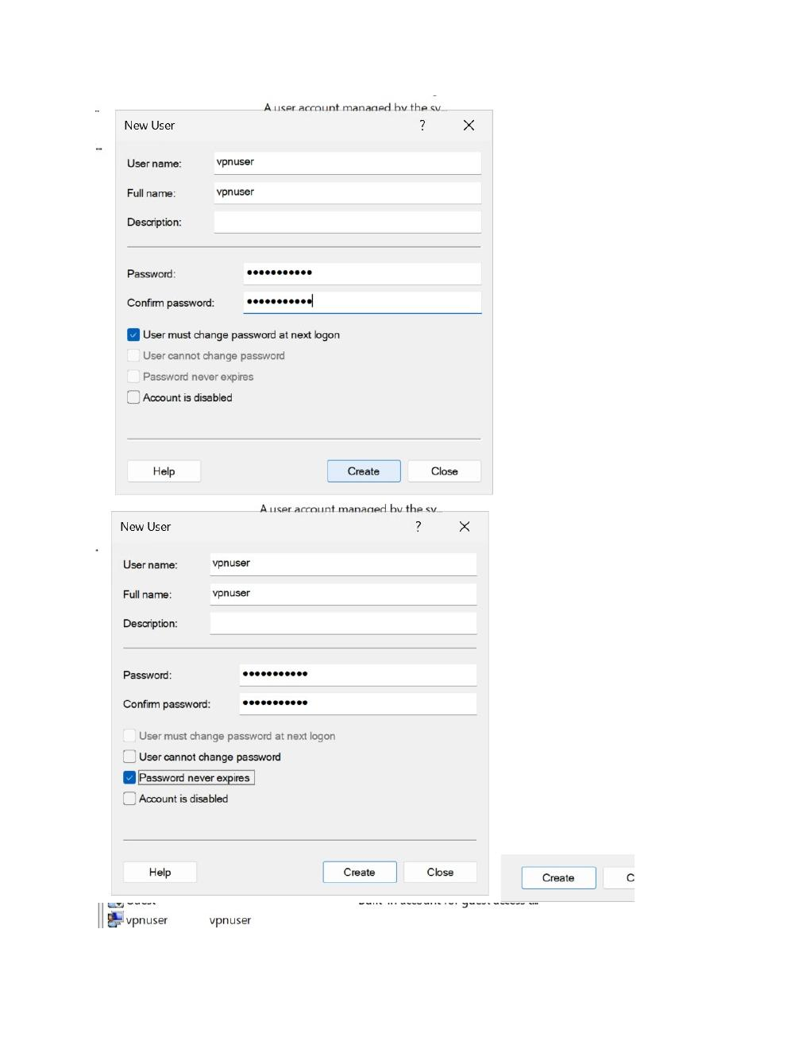
What I did:
Open the server/network configuration properties and verify the remote-access settings before testing the connection.

PAGE 34 — AWS VPC / WINDOWS VPN PRACTICAL
Topic: Screenshot-wise practical step
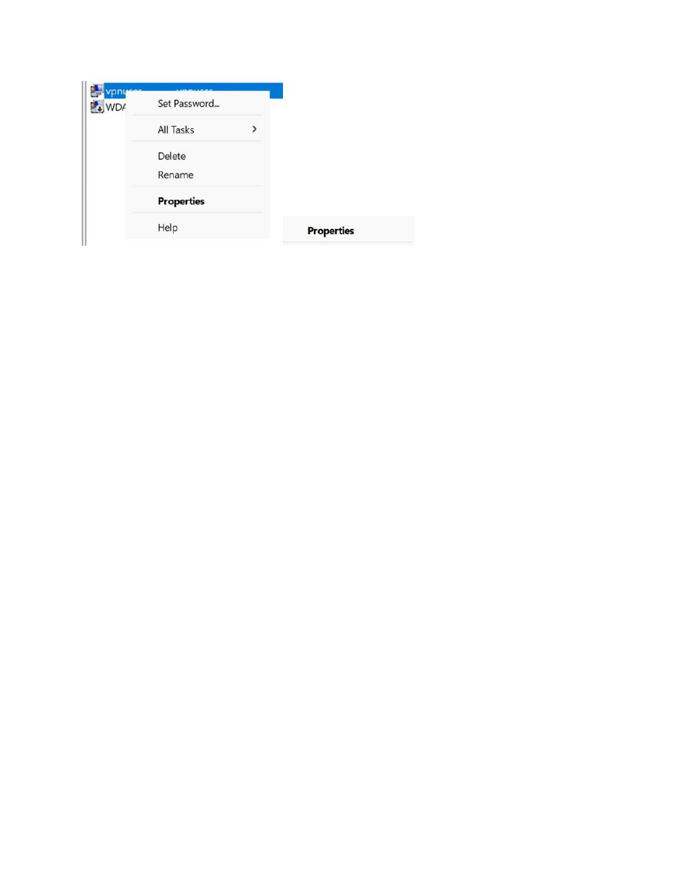
What I did:
Review the authentication/security settings used by the VPN server for incoming client connections.

PAGE 35 — AWS VPC / WINDOWS VPN PRACTICAL
Topic: Screenshot-wise practical step
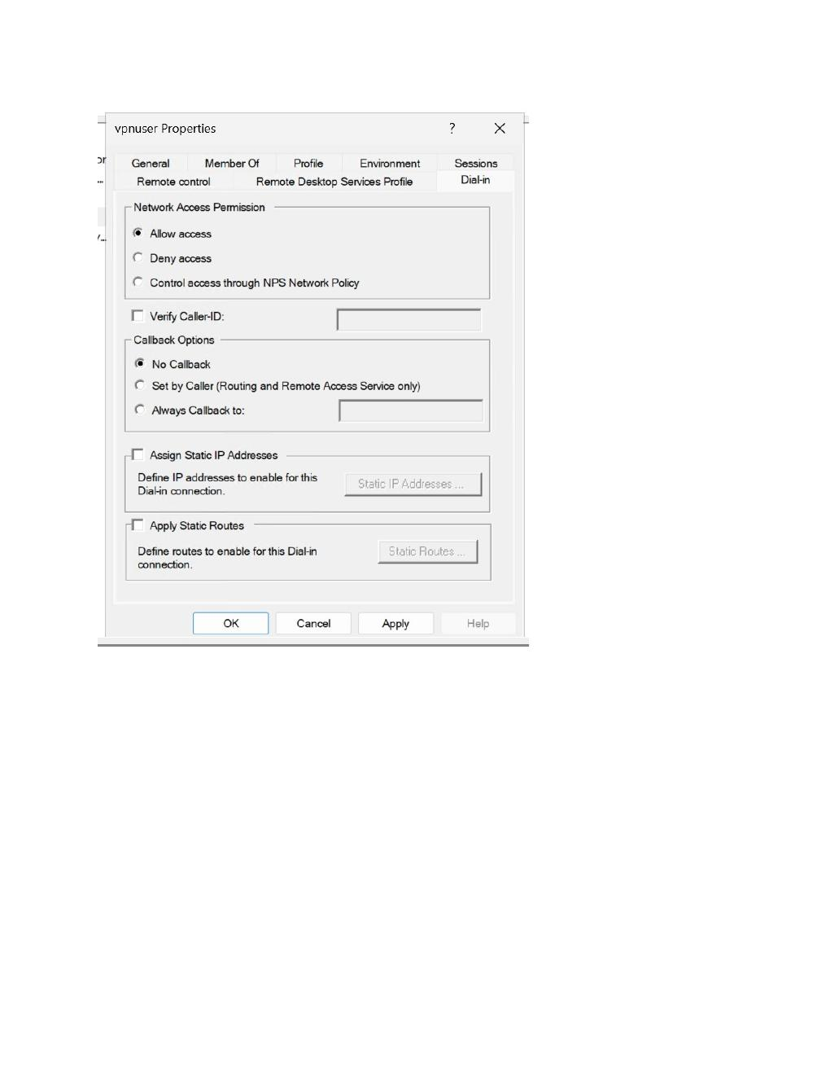
What I did:
Complete the Windows VPN server-side configuration and prepare the client side for a connection test.

PAGE 36 — AWS VPC / WINDOWS VPN PRACTICAL
Topic: Screenshot-wise practical step
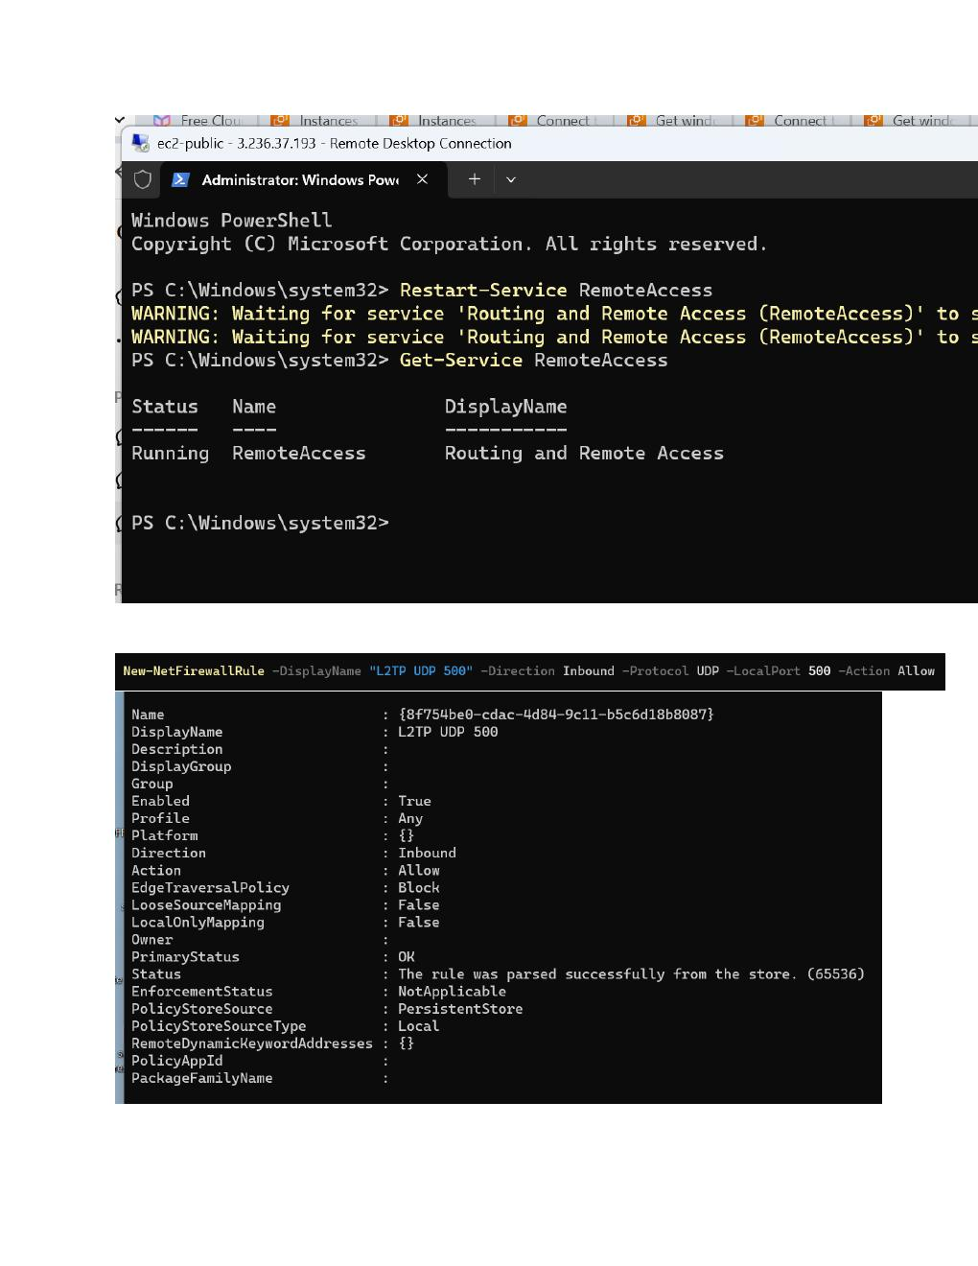
What I did:
Open the Windows client network/VPN settings and prepare a VPN connection to the AWS Windows Server.

PAGE 37 — AWS VPC / WINDOWS VPN PRACTICAL
Topic: Screenshot-wise practical step
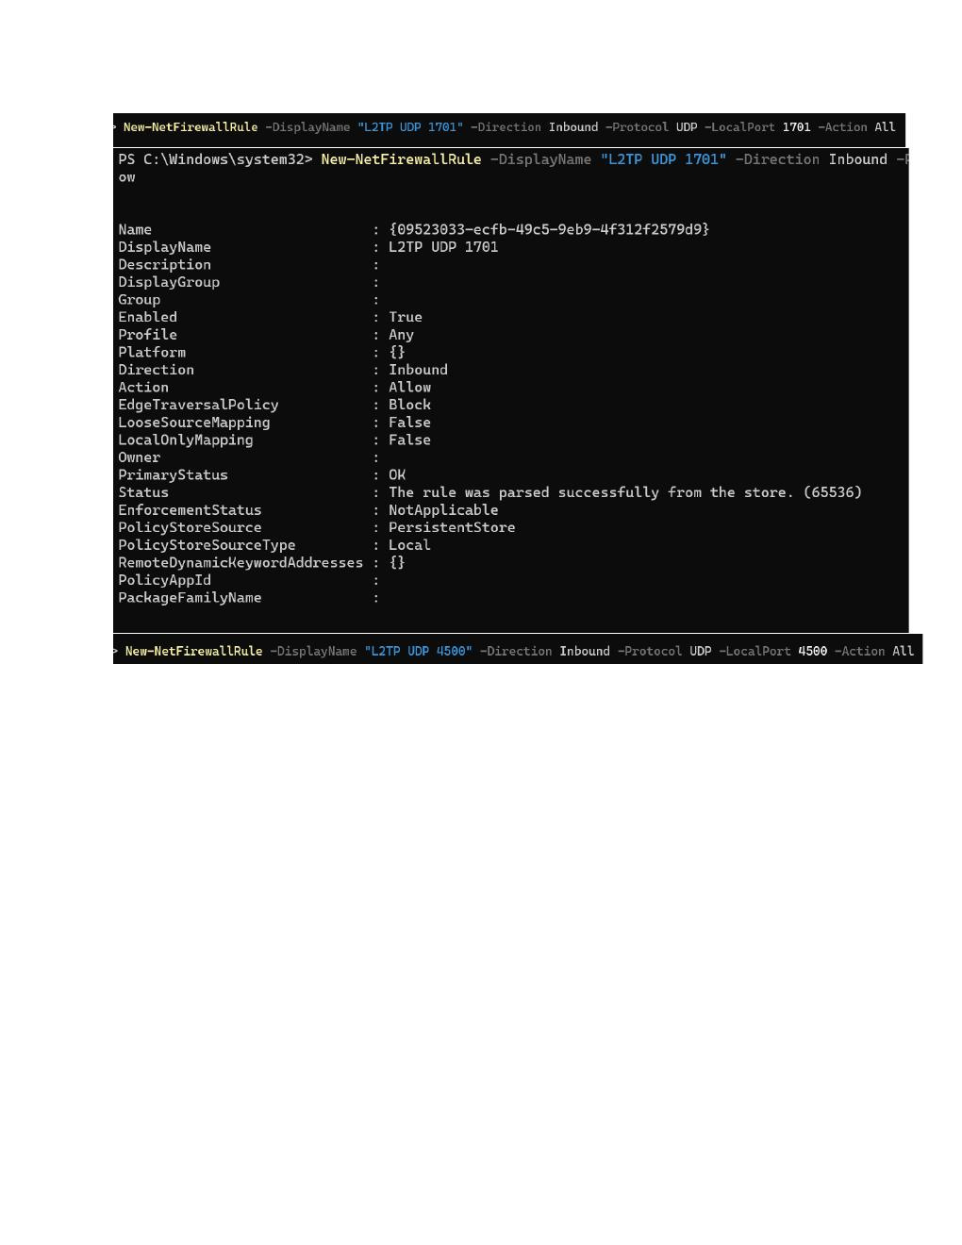
What I did:
Use Command Prompt on the client/server to verify the current network configuration and test connectivity.

PAGE 38 — AWS VPC / WINDOWS VPN PRACTICAL
Topic: Screenshot-wise practical step
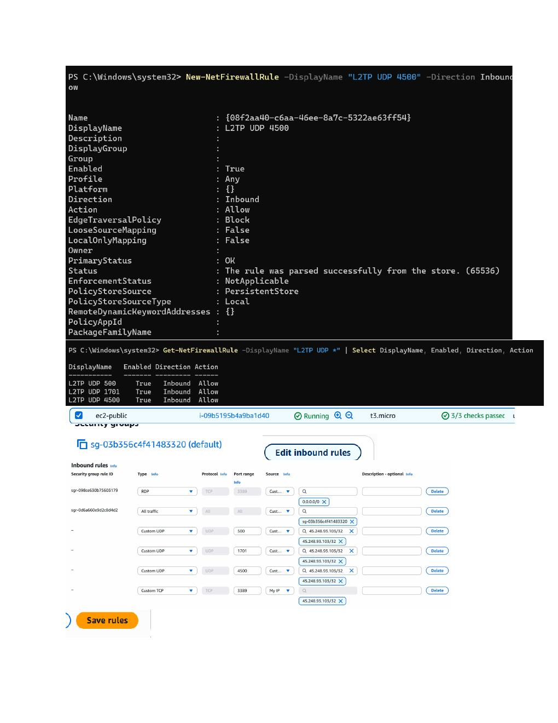
What I did:
Run network commands to check the VPN/server connection and inspect the returned IP/routing information.

PAGE 39 — AWS VPC / WINDOWS VPN PRACTICAL
Topic: Screenshot-wise practical step
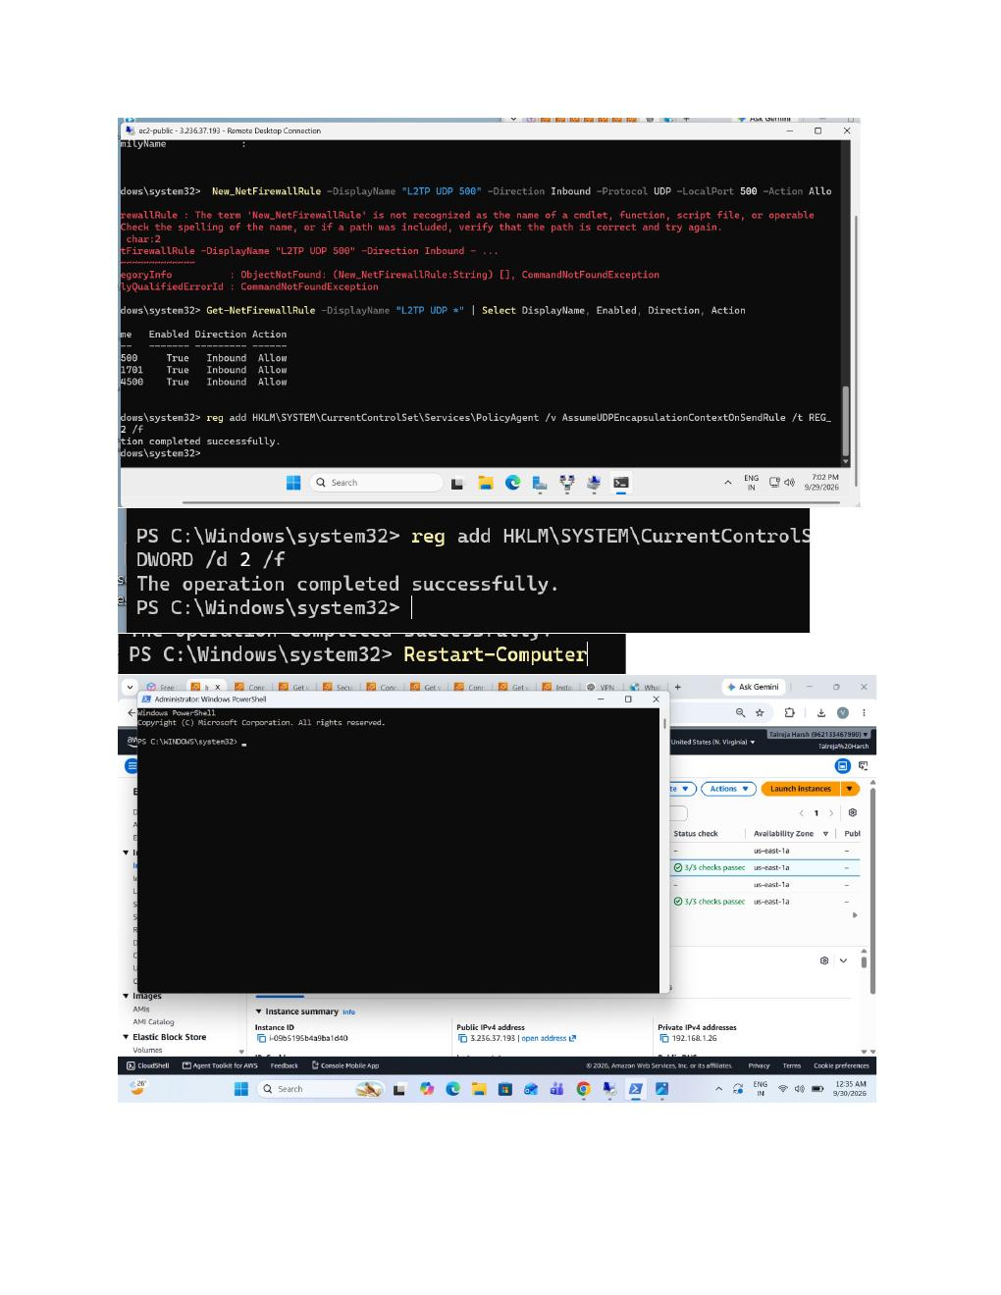
What I did:
Continue troubleshooting the VPN connection from Command Prompt; the screenshot shows command output/errors used to verify connectivity.

PAGE 40 — AWS VPC / WINDOWS VPN PRACTICAL
Topic: Screenshot-wise practical step
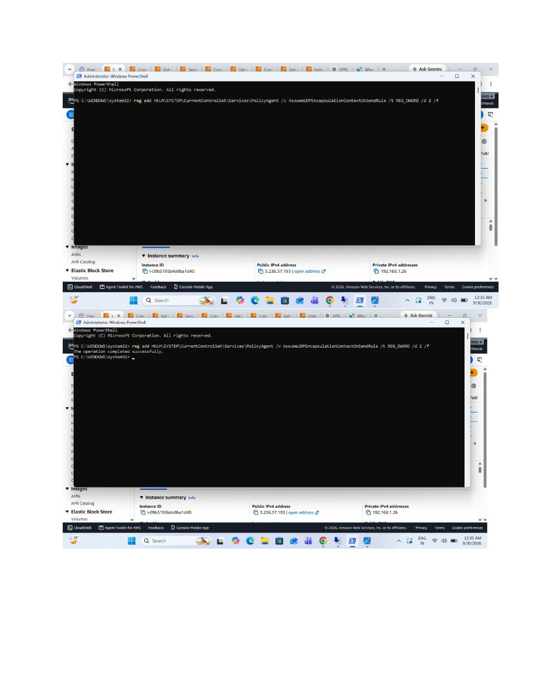
What I did:
Check the Windows network state together with the AWS console while testing the VPN and server connectivity.

PAGE 41 — AWS VPC / WINDOWS VPN PRACTICAL
Topic: Screenshot-wise practical step
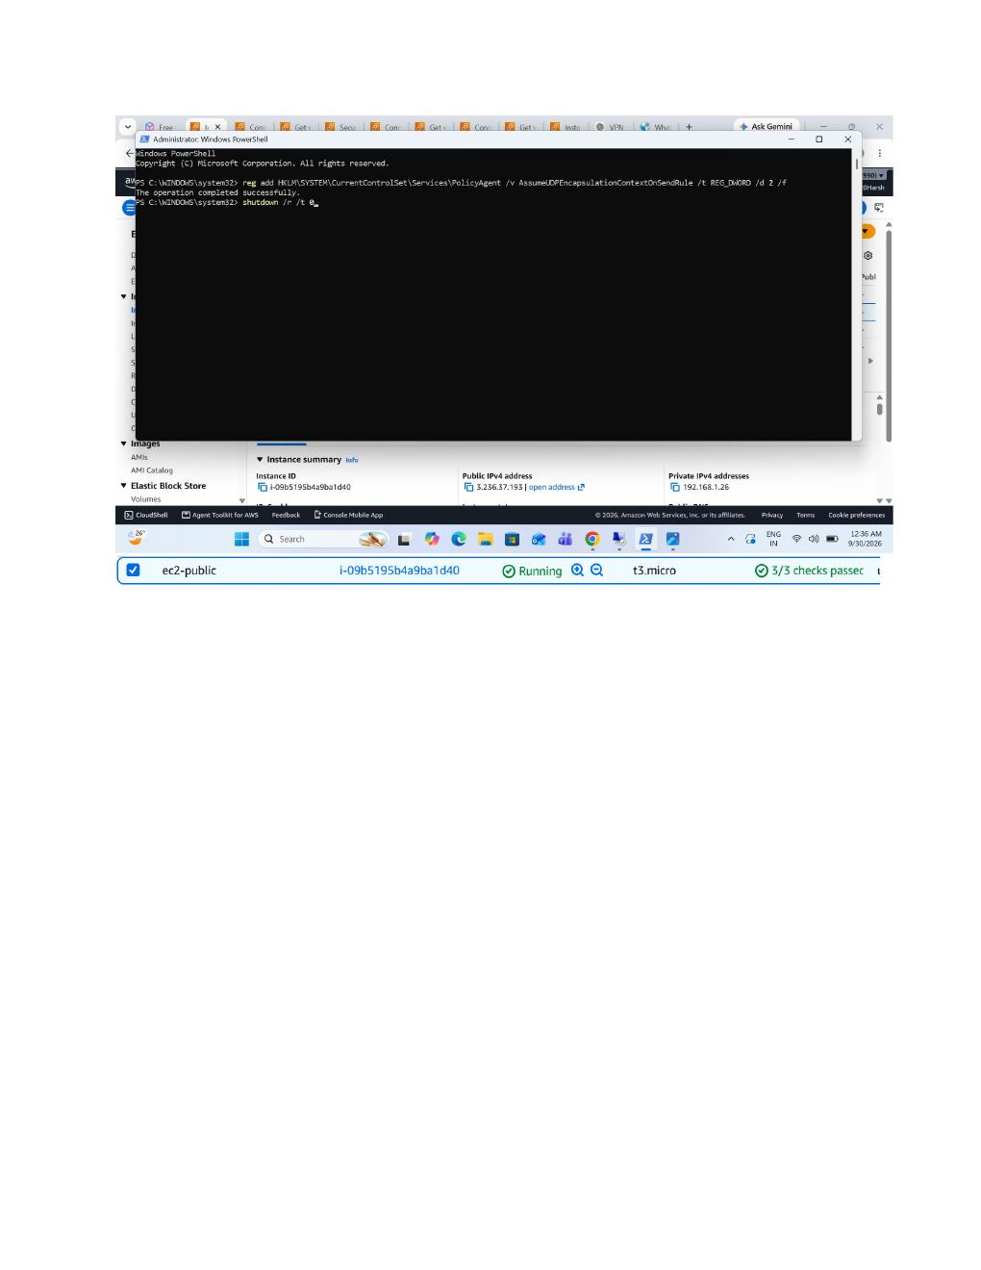
What I did:
Use Command Prompt to verify the VPN-assigned address and network routes after the connection is established.

PAGE 42 — AWS VPC / WINDOWS VPN PRACTICAL
Topic: Screenshot-wise practical step
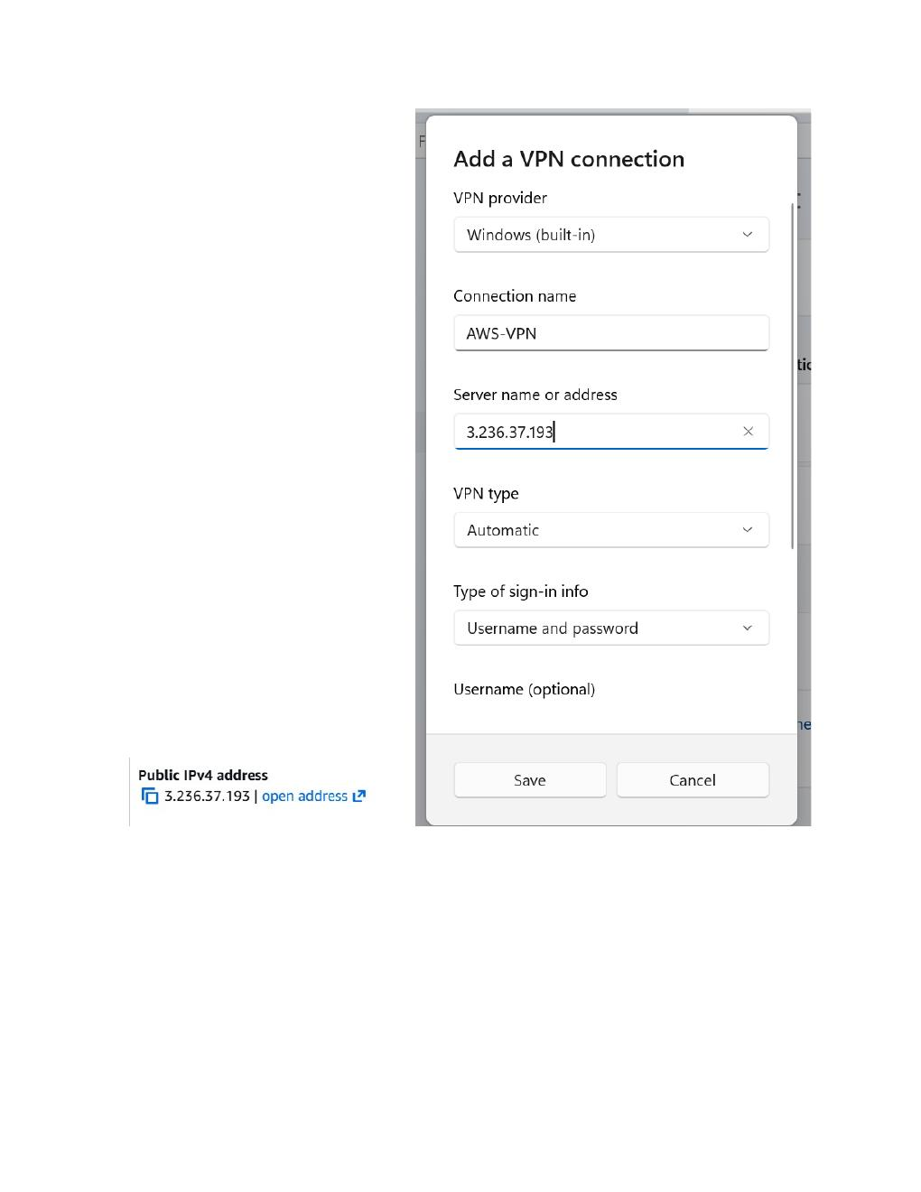
What I did:
Open the Windows VPN configuration screen and review the configured VPN connection details before connecting.

PAGE 43 — AWS VPC / WINDOWS VPN PRACTICAL
Topic: Screenshot-wise practical step
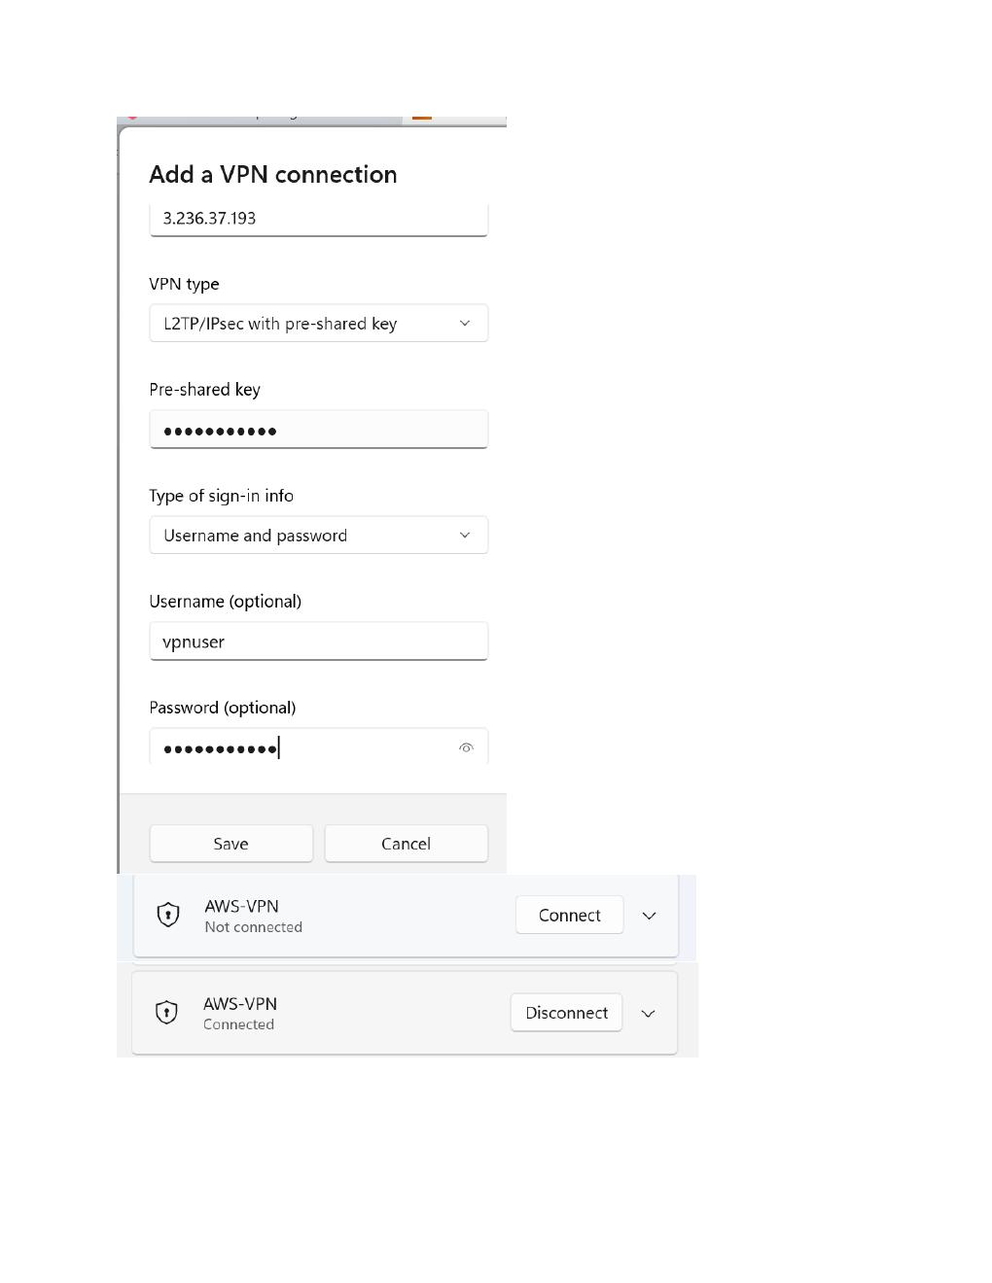
What I did:
Review the VPN connection settings and authentication information used by the Windows client.

PAGE 44 — AWS VPC / WINDOWS VPN PRACTICAL
Topic: Screenshot-wise practical step
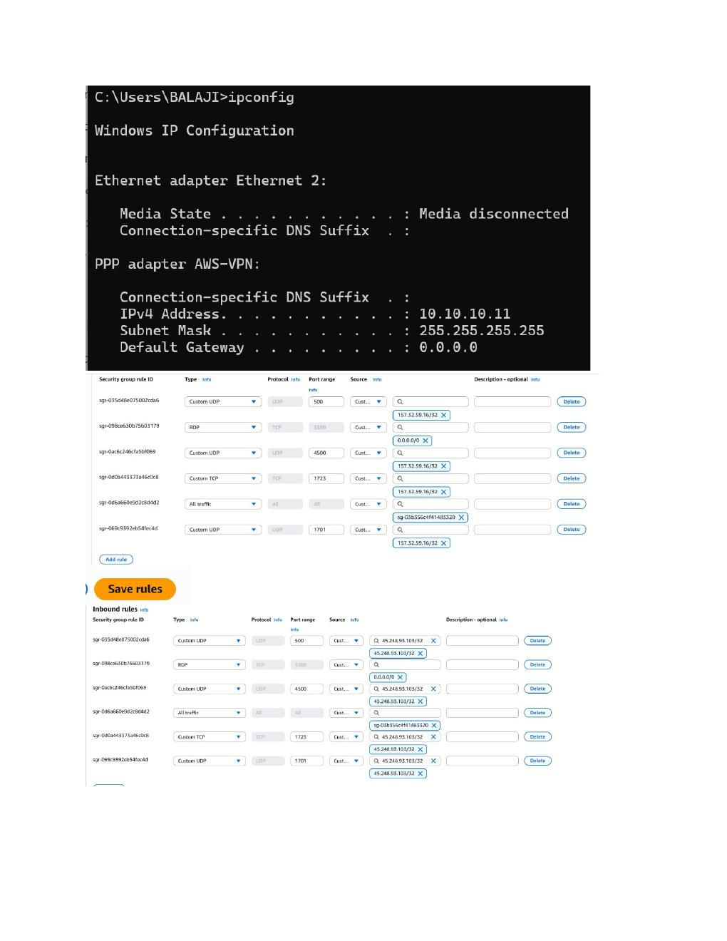
What I did:
Use Command Prompt to check the client IP configuration and confirm the VPN adapter/address after connecting.

PAGE 45 — AWS VPC / WINDOWS VPN PRACTICAL
Topic: Screenshot-wise practical step
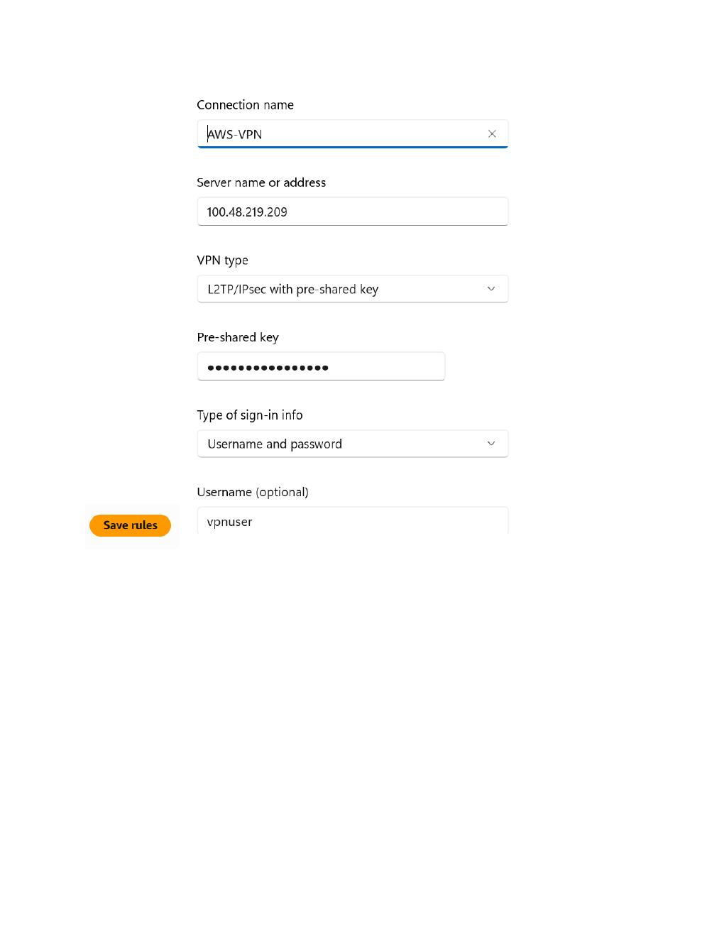
What I did:
Open the Windows VPN/network screen to verify the VPN connection state.

PAGE 46 — AWS VPC / WINDOWS VPN PRACTICAL
Topic: Screenshot-wise practical step
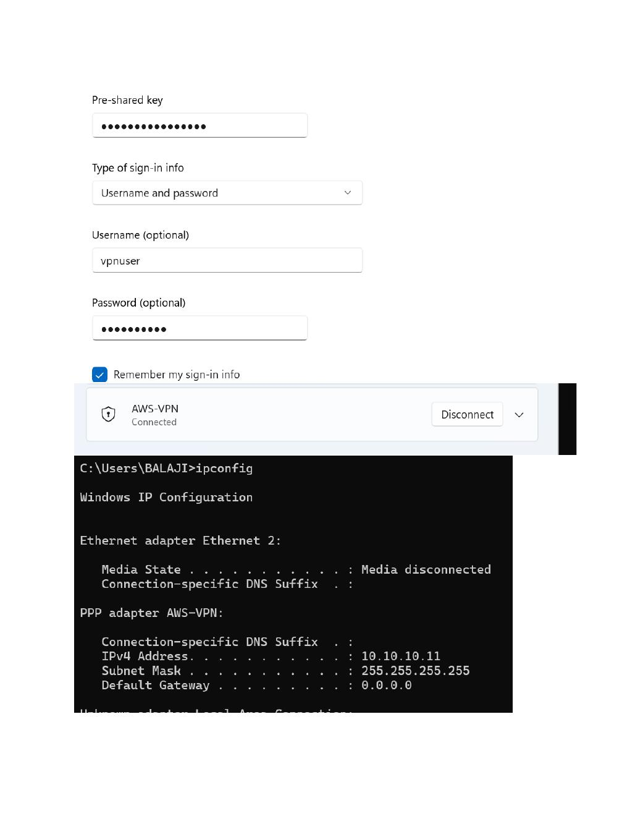
What I did:
Review the Windows network settings and VPN adapter while testing access to the AWS VPC.

PAGE 47 — AWS VPC / WINDOWS VPN PRACTICAL
Topic: Screenshot-wise practical step
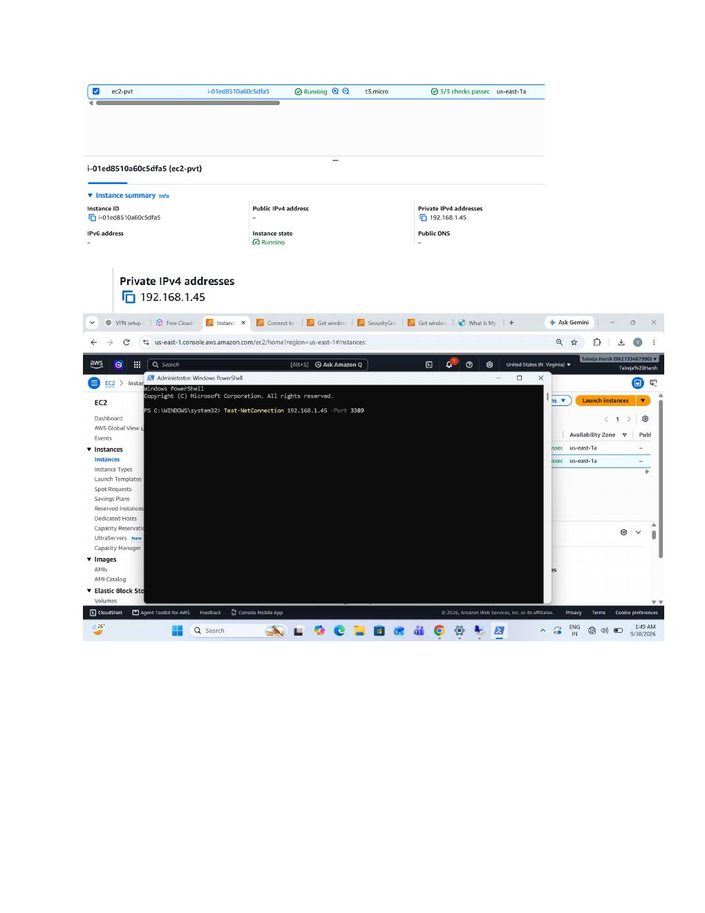
What I did:
Use Command Prompt together with the AWS console to verify connectivity to the private network/instance.

PAGE 48 — AWS VPC / WINDOWS VPN PRACTICAL
Topic: Screenshot-wise practical step
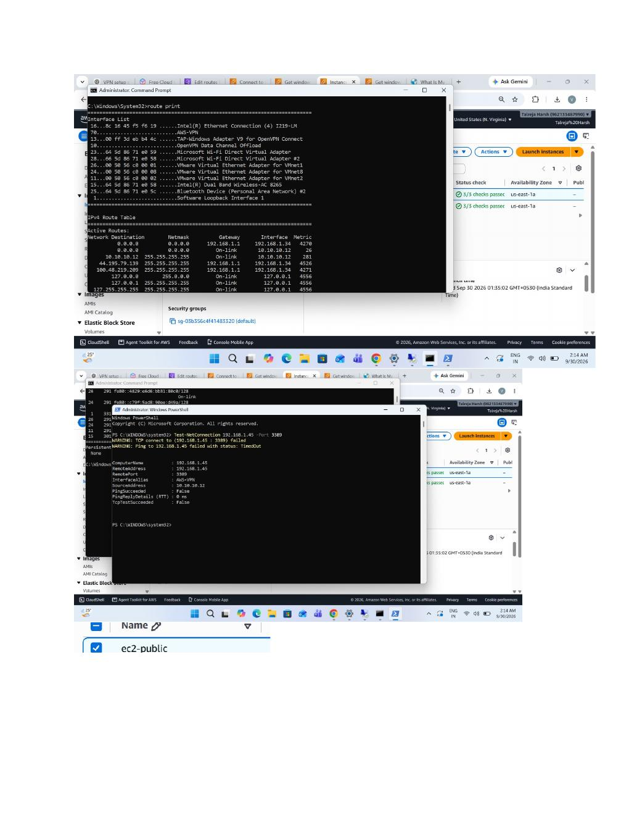
What I did:
Run additional network commands and inspect the AWS EC2/VPC state while troubleshooting the VPN path.

PAGE 49 — AWS VPC / WINDOWS VPN PRACTICAL
Topic: Screenshot-wise practical step
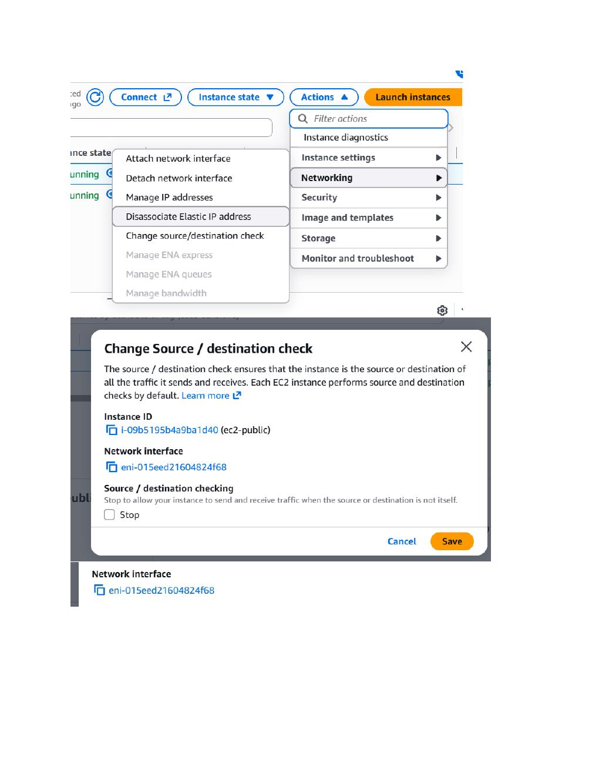
What I did:
Check the Windows command output for the VPN/private-subnet connectivity test and verify the corresponding AWS instance state.

PAGE 50 — AWS VPC / WINDOWS VPN PRACTICAL
Topic: Screenshot-wise practical step
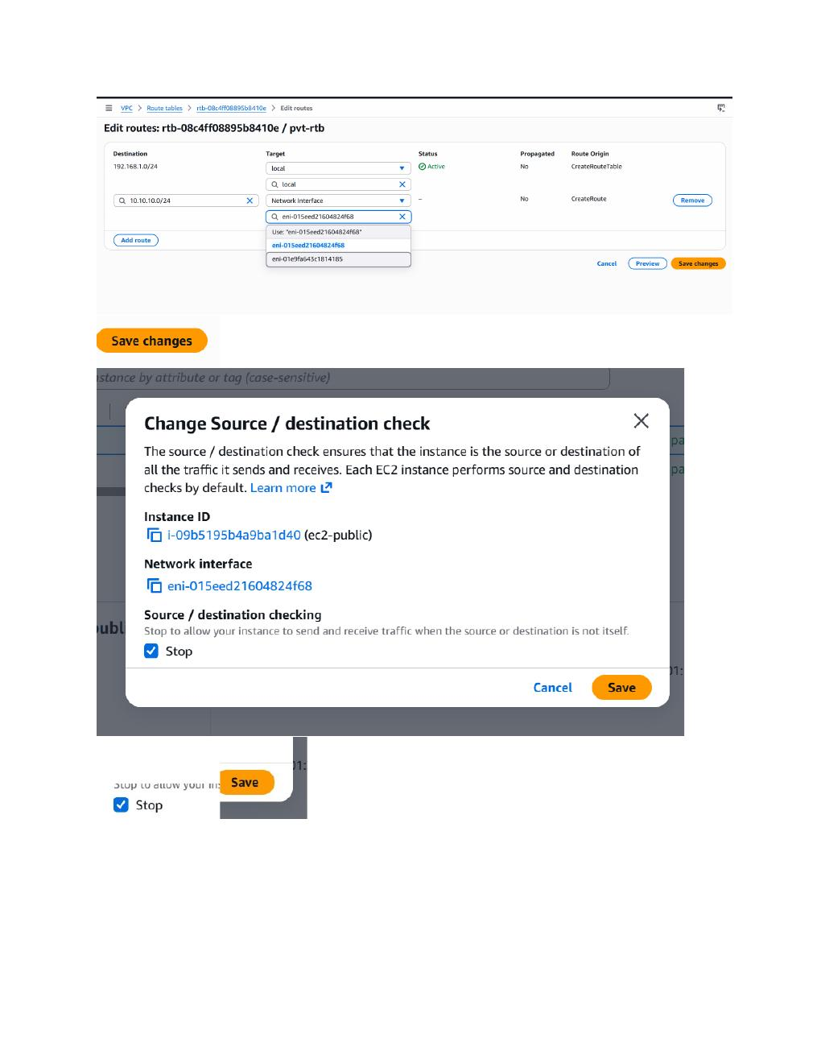
What I did:
Open the AWS EC2 console and verify that the Windows instances are running and that the networking configuration is available.

PAGE 51 — AWS VPC / WINDOWS VPN PRACTICAL
Topic: Screenshot-wise practical step
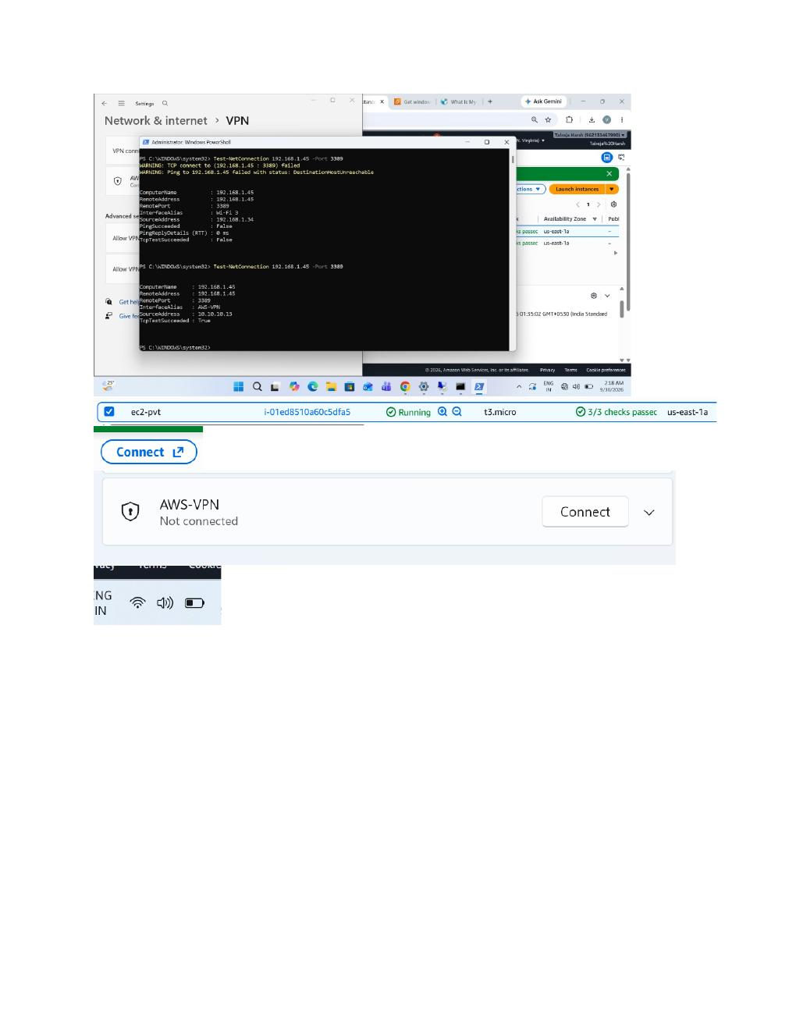
What I did:
Use Command Prompt to perform the final connectivity check while the AWS console shows the configured instances.

PAGE 52 — AWS VPC / WINDOWS VPN PRACTICAL
Topic: Screenshot-wise practical step
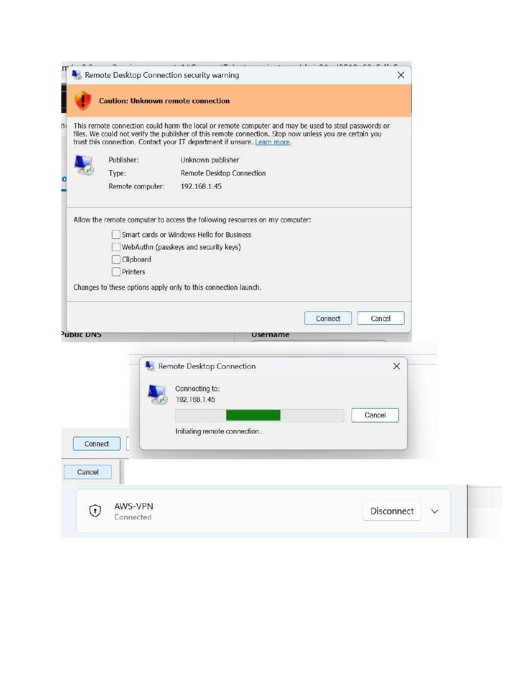
What I did:
Review the AWS/Windows connection result and the related security/network settings after the VPN test.

PAGE 53 — AWS VPC / WINDOWS VPN PRACTICAL
Topic: Screenshot-wise practical step
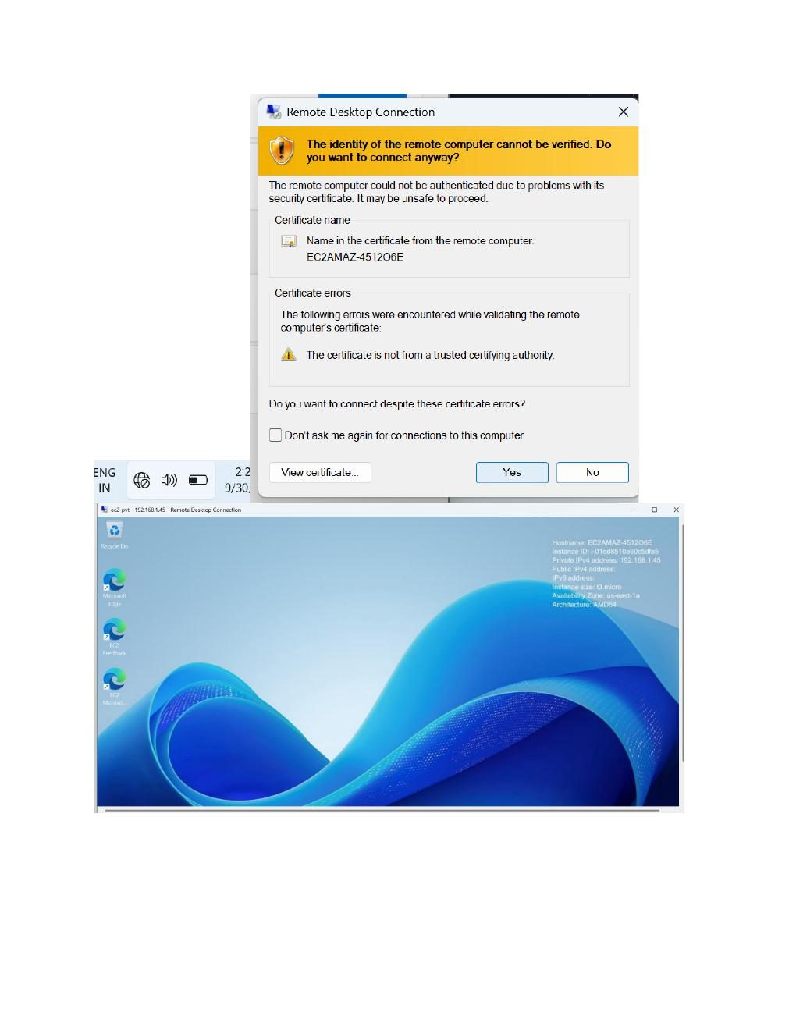
What I did:
Finish on the Windows client desktop after the VPN/network configuration and connectivity checks.

